Update on liquid target production and isolation of [⁶⁸Ga]GaCl₃
T. Erikssonª, J. Frigellª, K. Gagnon^{1,a}

ªGE Healthcare, GEMS PET Systems, Uppsala, Sweden

Introduction

Attributed both to the ease of acquiring ⁶⁸Ga by ⁶⁸Ge/⁶⁸Ga generators, and the approval and development of new tracers with theranostic relevance, there has been an ever-increasing use of ⁶⁸Ga over the last decade. However, since ⁶⁸Ge/⁶⁸Ga generators are limited due to: ⁶⁸Ga activity, the # of elutions, ⁶⁸Ge decay, and the need for monitoring of ⁶⁸Ge breakthrough, the direct cyclotron ⁶⁸Zn(p,n)⁶⁸Ga production route is an attractive alternative to ensuring a routine supply of ⁶⁸Ga.

Two strategies exist for producing ⁶⁸Ga via the ⁶⁸Z(p,n)⁶⁸Ga reaction – namely, liquid [1-4] and solid targets [5-6]. Liquid targets offer increased simplicity as they present a similar workflow to production of [¹⁸F]F⁻. If extraordinarily high ⁶⁸Ga activity is desired, solid targets offer order magnitude increases in yield, albeit solid targets are typically met with a trade-off of increased requirements on infrastructure and/or local site expertise.

Be it liquid or solid, the direct cyclotron route requires an efficient means for purifying the ⁶⁸Ga from the irradiated ⁶⁸Zn and for controlling the proton energy to limit co-production of ⁶⁷Ga to acceptable levels. Given the current cost of enriched ⁶⁸Zn, recycling is considered unnecessary.

In this work, we provide an update on liquid target production of ⁶⁸Ga, focusing on:

- Liquid target optimization/new target
- Chemical isolation of [⁶⁸Ga]GaCl₃
- Quality control, with a focus on radionuclidic purity and residual metals

Material and Methods

Irradiations were performed on a GE PETtrace cyclotron. The target media was comprised of zinc nitrate in dilute nitric acid, first using ^{nat}Zn, and ultimately moving to ⁶⁸Zn. ⁶⁸Ga yields were assessed by means of curve fitting/stripping of multiple dose calibrator measurements assayed for ~1-5 hrs (^{nat}Zn) or ~1-3 hrs (⁶⁸Zn).

The zinc and nitric acid concentrations were optimized considering ⁶⁸Ga yield, ⁶⁸Zn consumption, and ease of solution transfer to a hotcell.

Several liquid target designs were also considered and tested, including development of a new helium-cooling-free target with integrated energy degrader (Figure 1). Other than the PEEK fill lines, all target designs had only niobium as a contact material with the target media.

Figure 1. GE PETtrace 2mL ⁶⁸Ga target with integrated energy degrader

Chemical isolation as [⁶⁸Ga]GaCl₃ was implemented on the GE FASTlab Developer Platform. In this scheme [7] (Figure 2), ⁶⁸Ga is first trapped on hydroxamate resin (2 mL [~700 mg] ZR resin, Triskem), washed with 14 mL 0.1 M HNO₃ and eluted as [⁶⁸Ga]GaCl₃ in 5 mL ~1.5 M HCl. The eluate is then efficiently trapped on TK200 resin (2 mL [~700 mg]) without the need for first increasing the HCl concentration. Finally, after purging with nitrogen, the trapped [⁶⁸Ga]GaCl₃ is eluted in 3 mL water.

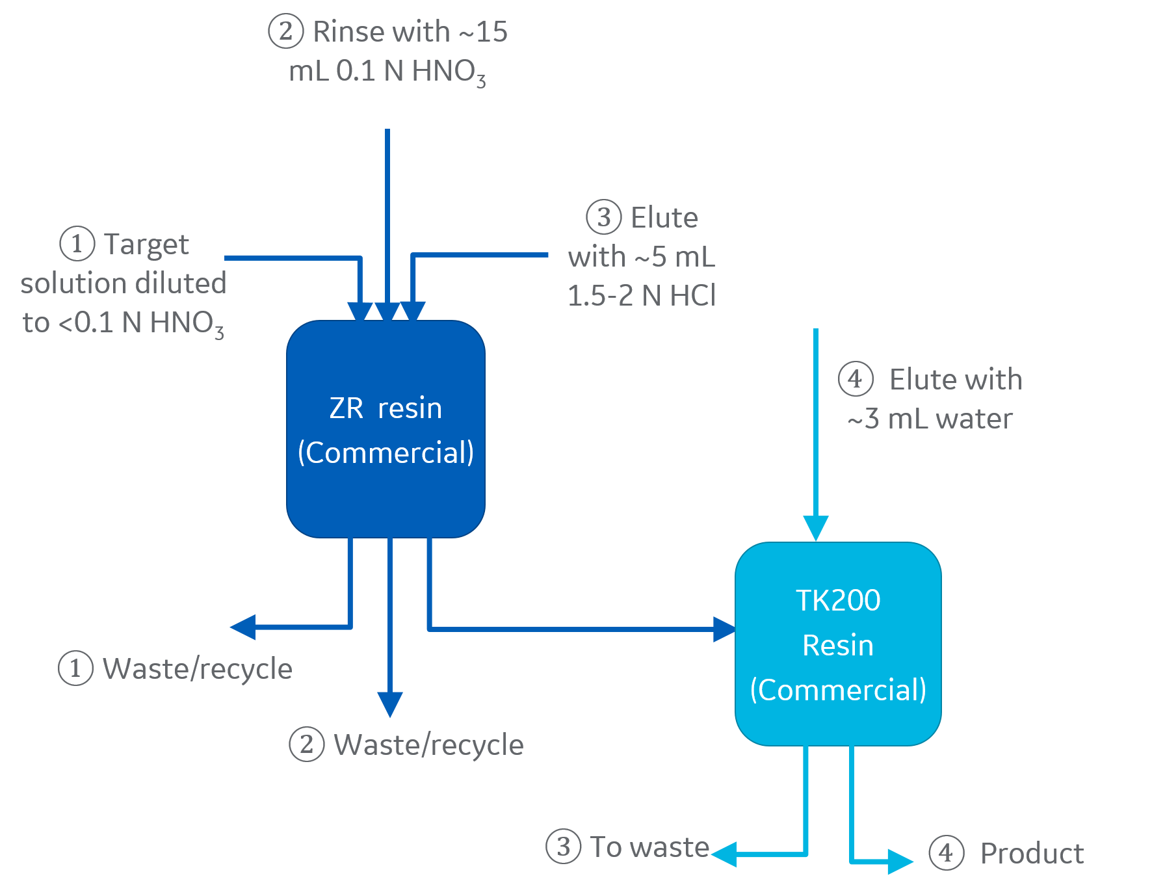
Figure 2. [⁶⁸Ga]GaCl₃ isolation scheme
Quality control (QC) tests were performed on the extracted [⁶⁸Ga]GaCl₃ (e.g. half-life, radiochemical purity (RCP), etc), however, considerable effort was directed towards both the radionuclidic purity (RNP), and the residual metal content pre/post chemical purification.

The RNP was assessed for two different lots of ⁶⁸Zn (Table 1), each lot of which was irradiated at 4 different nominal proton energies from ~13 to 15 MeV. The contribution of ⁶⁶Ga and ⁶⁷Ga was determined by gamma spectroscopy with a LaBr detector (efficiency calibrated using ¹³⁷Cs and ¹⁵²Eu sources), with samples analysed ~20-40 hrs post end-of-bombardment (EOB). No other non-^{6x}Ga gammas were identified.

Table 1. Experimental lots of enriched ⁶⁸Zn
 | ⁶⁴Zn  [%] | ⁶⁶Zn  [%] | ⁶⁷Zn  [%] | ⁶⁸Zn  [%] | ⁷⁰Zn  [%]
A | 0.76 | 0.61 | 0.27 | 98.33 | 0.03
B | 0.03 | 0.16 | 0.62 | 99.16 | 0.03
Nat | 49.17 | 27.73 | 4.04 | 18.45 | 0.61

In the context of metal content, the European Pharmacopoeia monograph for generator-based [⁶⁸Ga]GaCl₃ notes limits of 10 μg/GBq for each of iron and zinc. While it is possible to perform this test with adequate sensitivity using commercially available colorimetric test strips, for completeness, we have screened for ~70 elements via ICP-MS on a selection of sample retains of both irradiated (but not chemically processed) and also samples of chemically isolated [⁶⁸Ga]GaCl₃. Such samples have spanned the development phase. Use of the m/z=68 channel and appropriate isotopic abundance was used for analysis of zinc.

Results and Discussion

To optimize the production of ⁶⁸Ga, it is not only a matter of optimizing the yield of ⁶⁸Ga; one must also consider ⁶⁸Zn consumption and ease of handling. As noted in Figure 3, (i.e. 15.2 MeV, 10 μA, t_{b} = 30 minutes, ^{nat}Zn(NO₃)₂ in 0.2 M HNO₃), the yield of ⁶⁸Ga increased linearly with zinc concentration. However, such a result was limited only to low beam currents. As beam current was increased, pressures were undesirably elevated for the higher zinc concentrations. Furthermore, at high zinc concentrations, transfer to the hotcell was slow, if not impossible, for long transfer distances. We have therefore opted for a target media of 1.0 M [⁶⁸Zn]Zn(NO₃)₂ in 0.2 M excess HNO₃.
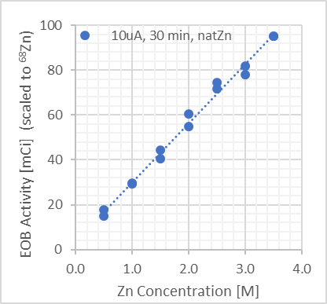
Figure 3. ⁶⁸Ga yield vs. Zn concentration

Several technical challenges in existing chemistry methods for separating ⁶⁸Ga from bulk ⁶⁸Zn include, but are not limited to, high HCl concentration/volume, use of organic solvents, base-mediated pH adjustment, non-commercially available resins, etc. In addition, our goal was to implement the chemistry onto a FASTlab cassette, including not only the chemistry, but also column conditioning, and furthermore, leaving adequate space on the cassette to perform peptide labelling on the same cassette.

Table 2 presents the combined results of ⁶⁸Ga production with the optimized target media in the new PETtrace ⁶⁸Ga liquid target followed by [⁶⁸Ga]GaCl₃ separation on a FASTlab using the scheme presented above. We note that with a 1 hour irradiation using a liquid target, and ~23 minutes chemical processing, it is possible to achieve [⁶⁸Ga]GaCl₃ of similar chemical form with a ⁶⁸Ga radioactivity in excess of a typical generator elution.

Table 2. Triplicate productions of [⁶⁸Ga]GaCl₃ [7]
Parameter/Test | Value
Irradiation conditions | 14 MeV/60 min/30 μA
Total ⁶⁸Ga at EOB | 4.4(1) GBq (120(4) mCi)
[⁶⁸Ga]GaCl₃ @ 30 min EOB | 2.5(1) GBq (68(4) mCi)
Radiochemical yield | 77(2) %
Half-life | 67.6(2) minutes
pH | <2
Iron/zinc | Each <10 µg/GBq
RCP | 99(1) %
Appearance | Clear, colourless

In the context of RNP, both ⁶⁶Ga and ⁶⁷Ga are co-produced. Table 3 reports the experimental ⁶⁶Ga and ⁶⁷Ga measurements for two commercial lots of ⁶⁸Zn, irradiated at 4 different energies. As the irradiation time was not always the same, the saturation yields of ⁶⁶Ga and ⁶⁷Ga were calculated, and, for purpose of comparison, a 68-minute irradiation was assumed. These results confirm that the contribution of ⁶⁶Ga is largely due to the contribution of ⁶⁶Zn in the starting material, whereas the ⁶⁷Ga content is energy dependent, with the contribution of ⁶⁸Zn(p,2n)⁶⁷Ga outweighing the contribution from ⁶⁷Zn(p,n)⁶⁷Ga for energies greater than ~13 MeV.

Table 3. RNP (assuming a 68 minute irradiation)
E  [MeV] | N | Lot  ⁶⁸Zn | ⁶⁸Ga  [%] | ⁶⁷Ga  [%] | ⁶⁶Ga  [%]
13.1 | 3 | A | 99.94 | 0.0073(4) | 0.057(5)
14.0 | 7 | A | 99.86 | 0.079(8) | 0.062(5)
14.5 | 2 | A | 99.84 | 0.103(5) | 0.055(7)
15.2 | 4 | A | 99.72 | 0.207(12) | 0.072(8)
13.1 | 3 | B | 99.98 | 0.0130(3) | 0.0096(6)
14.3 | 16 | B | 99.90 | 0.091(9) | 0.0099(8)
14.5 | 3 | B | 99.89 | 0.104(6) | 0.0083(13)
15.2 | 4 | B | 99.80 | 0.194(8) | 0.009(4)

In assessing metal impurities, data is tabulated (Table 4) for both Zn and Fe (in μg/mL), as well as 8 other impurities (in ng/mL) for irradiation only “irrad“, and chemically isolated [⁶⁸Ga]GaCl₃ "chem”. These additional impurities are of interest due to known target contact materials, noted chemical variation between ⁶⁸Zn lots, potential concern for competing for DOTA chelation, etc., however, we note that these are generally reduced to the single-to-low-tens of ng/mL following chemical purification. It is also important to emphasize that ICP-MS data presented below spanned the duration of the development period, some experiments of which were performed with ACS grade reagents, with such data included to emphasize robustness of the isolation scheme. Current levels of ⁶⁸Zn are now routinely below 1 μg/mL, with further reduction demonstrated with additional column rinsing.

Table 4. Select elemental impurities [8]
 |  | Zn Lot A |  | Zn Lot B
 |  | Irrad  (n=3) | Chem  (n=9) | Irrad  (n=5) | Chem  (n=6)
μg | Zn | 48583(365) | 2.8(34) | 55183(1066) | 0.73(0.48)
/mL | Fe | 1.13(12) | 0.24(12) | 0.98(13) | 0.18(12)
ng | Ni | 1318(118) | 18(11) | 214(35) | 19(13)
/mL | Cu | 1615(121) | 8.8(61) | 1147(152) | 4.7(12)
 | Co | 85(74) | 0.28(19) | 3.8(11) | 0.150(55)
 | Cr | 37(20) | 22(24) | 46.0(87) | 10.2(52)
 | Y | 0.60(10) | 0.38(14) | 0.380(45) | 0.283(75)
 | Nb | 21(35) | 0.046(14) | 18(35) | 0.14(11)
 | Sn | 9(12) | 1.19(61) | 335(192) | 21(29)
 | Cd | 4.6(35) | 0.19(15) | 1940(87) | 0.22(12)

Conclusion

We have presented a new PETtrace ⁶⁸Ga target with an integrated energy degrader and we have developed and implemented a 2-column approach to isolate cyclotron-based [⁶⁸Ga]GaCl₃ on the FASTlab Developer platform. Results demonstrate it is possible to achieve [⁶⁸Ga]GaCl₃ with a ⁶⁸Ga activity in excess of a typical generator elution. We note that the content of ⁶⁶Ga and ⁶⁷Ga may be reduced to acceptable levels [9] by selection of enriched ⁶⁸Zn low in ⁶⁶Zn, and by reduction of the proton energy. Analysis of residual metals supports the current applicability of cyclotron-based production of ⁶⁸Ga and anticipated robustness as novel ligands and chelators are developed and introduced.

References
1. A.T.J. Vogg, R. Lang, P. Meier-Böke, W. Scheel, S.N. Reske, B. Neumaier: 6th International Conference on Nuclear and Radiochemistry, Aachen, Germany, 2004.
2. M. Jensen, J. Clark, 13th Workshop on Targetry and Target Chemistry, Roskilde, Denmark, 2010.
3. E. Oehlke, C. Hoehr, X. Hou, V. Hanemaayer, S. Zeisler, M.J. Adam, T.J. Ruth, A. Celler, K. Buckley, F. Benard, P. Schaffer: Nucl. Med. Biol. 42, pp. 842-849, 2015.
4. M.K. Pandey, N.R. Schmit, J.M. McEarchern, T.R. DeGrado, 16th Workshop on Targetry and Target Chemistry, Santa Fe, NM, USA, 2016.
5. J.W. Engle, V.Lopez-Rodriguez, R.E. Gaspar-Carcamo, H.F. Valdovinos, M. Valle-Gonzalez, F. Trejo-Ballado, G.W. Severin, T.E. Barnhart, R.J. Nickles, M.A. Avila-Rodriguez: Appl. Radiat. Isot. 70, pp. 1792-1796, 2012.
6. M. Lin, G. Waligorski, C.G. Lepera: Appl. Radiat. Isot. 133, pp. 1-3, 2018.
7. M. Nair, S. Happel, T. Eriksson, M.K. Pandey, T.R. DeGrado, K. Gagnon: Eur. J. Nucl. Med. Mol. Imaging. 44 (Suppl 2), pp., S119-S956, 2017.
8. J. Frigell, K. Gagnon, 19th European Symposium on Radiopharmacy and Radiopharmaceuticals, Groningen, 2018.
9. S.A. Graves, J. W. Engle, T.E. Eriksson, K. Gagnon, Annual meeting of the SNMMI, Philadelphia, 2018.

