High yield production and chemical isolation of high radionuclidic purity bromine-80m for targeted Auger radionuclide therapy
PA Ellison¹, AP Olson, TE Barnhart, RJ Nickles, JW Engle

Department of Medical Physics, University of Wisconsin School of Medicine and Public Health, Madison, WI, United States

Introduction
Recently, the field of targeted internal radionuclide therapy has gained significant interest, especially using radionuclides that emit low energy Auger and conversion electrons [1]. The vast majority of these radionuclides are metals. They are used in the labeling of large biological targeting vectors with a ~0.5 kDa chelator, but these chelators obscure the pharmacokinetics of smaller molecules such as sugars, nucleosides, neurotransmitters, and hormones. Non-metal radionuclides that can form covalent bonds with organic structures must still be employed as radiolabels for these small molecules. Radiobromine is attractive because it is readily incorporated into small molecules through well characterized electrophilic and nucleophilic organo-bromination chemistries [2] and because it offers several radioisotopes with desirable physical properties (see Table 1).

 | t_{1/2} | Production reaction (%nat abun.) | Application
⁷⁶Br | 16 h | ⁷⁶Se(p,n) (9.4%) | PET
⁷⁷Br | 57 h | ⁷⁷Se(p,n) (7.6%) | Auger therapy
^{80m}Br | 4.4 h | ⁸⁰Se(p,n) (50%) | Auger therapy
⁸²Br | 35 h | ⁸²Se(p,n) (8.7%) | β– therapy
Table 1. Properties of radiobromine isotopes.

The small cyclotron production of radiobromine is accomplished through the proton irradiation of selenium, an element with low vapor pressure and poor thermal conductivity. While thin elemental selenium targets have notably been used to produce ^{80m}Br [3], the most successful productions of ⁷⁷Se have iradiated metal selenides, such as Cu₂Se [4, 5,6] or NiSe [7] and isolated radiobromine with thermochromatographic distillation. With these targets, proton irradiation intensities are limited to ≤ 20 μA, allowing for the production of ~0.7 GBq quantities of ⁷⁷Br [5] and < 10 GBq quantities of ^{80m}Br [3] with the use of isotopically enriched selenium targets. Once radioisolation and radiochemical yields are taken into consideration, these quantities are inadequate for even preclinical studies of targeted ^{80m}Br- and ⁷⁷Br-labeled radiotherapeutics. In this work, we have investigated new methods for the production of radionuclidically pure ^{80m}Br and ⁷⁷Br through the high intensity irradiation of the new target material CoSe, allowing for the production of ~10 GBq ^{80m}Br with high radionuclidic purity.

Material and Methods
Synthesis of CoSe target material:
Cobalt (110 mg, Alfa Aesar) and natural enrichment selenium (150 mg, Acros Organics) or 99.9% selenium-80 (Isoflex USA) powder were weighed into a quartz test tube. The quartz tube was purged through multiple alternations of roughing pump vacuum and argon gas and sealed at vacuum. The ampule was heated to 1200 °C for 60 - 150 minutes in an electric resistance furnace and immediately quenched afterwards in water. The resulting CoSe pellets were set into coin backing materials as described below.

Production of CoSe coin targets:
Cyclotron “coin” targets were made by hot-pressing CoSe into a 9.5-mm-diameter, 1-mm-deep pocket of a 19 mm diameter, 1.5 - 2 mm thick niobium or cobalt coin using the vertical tube furnace assembly shown in Figure 1. The coin was placed on the bottom of the outer quartz tube with a ~250 mg CoSe pellet in its pocket under a boron nitride tamper. The assembly was purged with 40 - 60 mL/min Ar flow and lowered into a 1100 °C furnace. After 5 - 20 minutes of heating, the top compression fitting was loosened and the quartz outlet tube used to apply downward pressure on the BN tamper, compressing the CoSe into the coin pocket. The assembly was then removed from the furnace and quenched in water. This process was repeated several times until the CoSe coin appeared uniform.

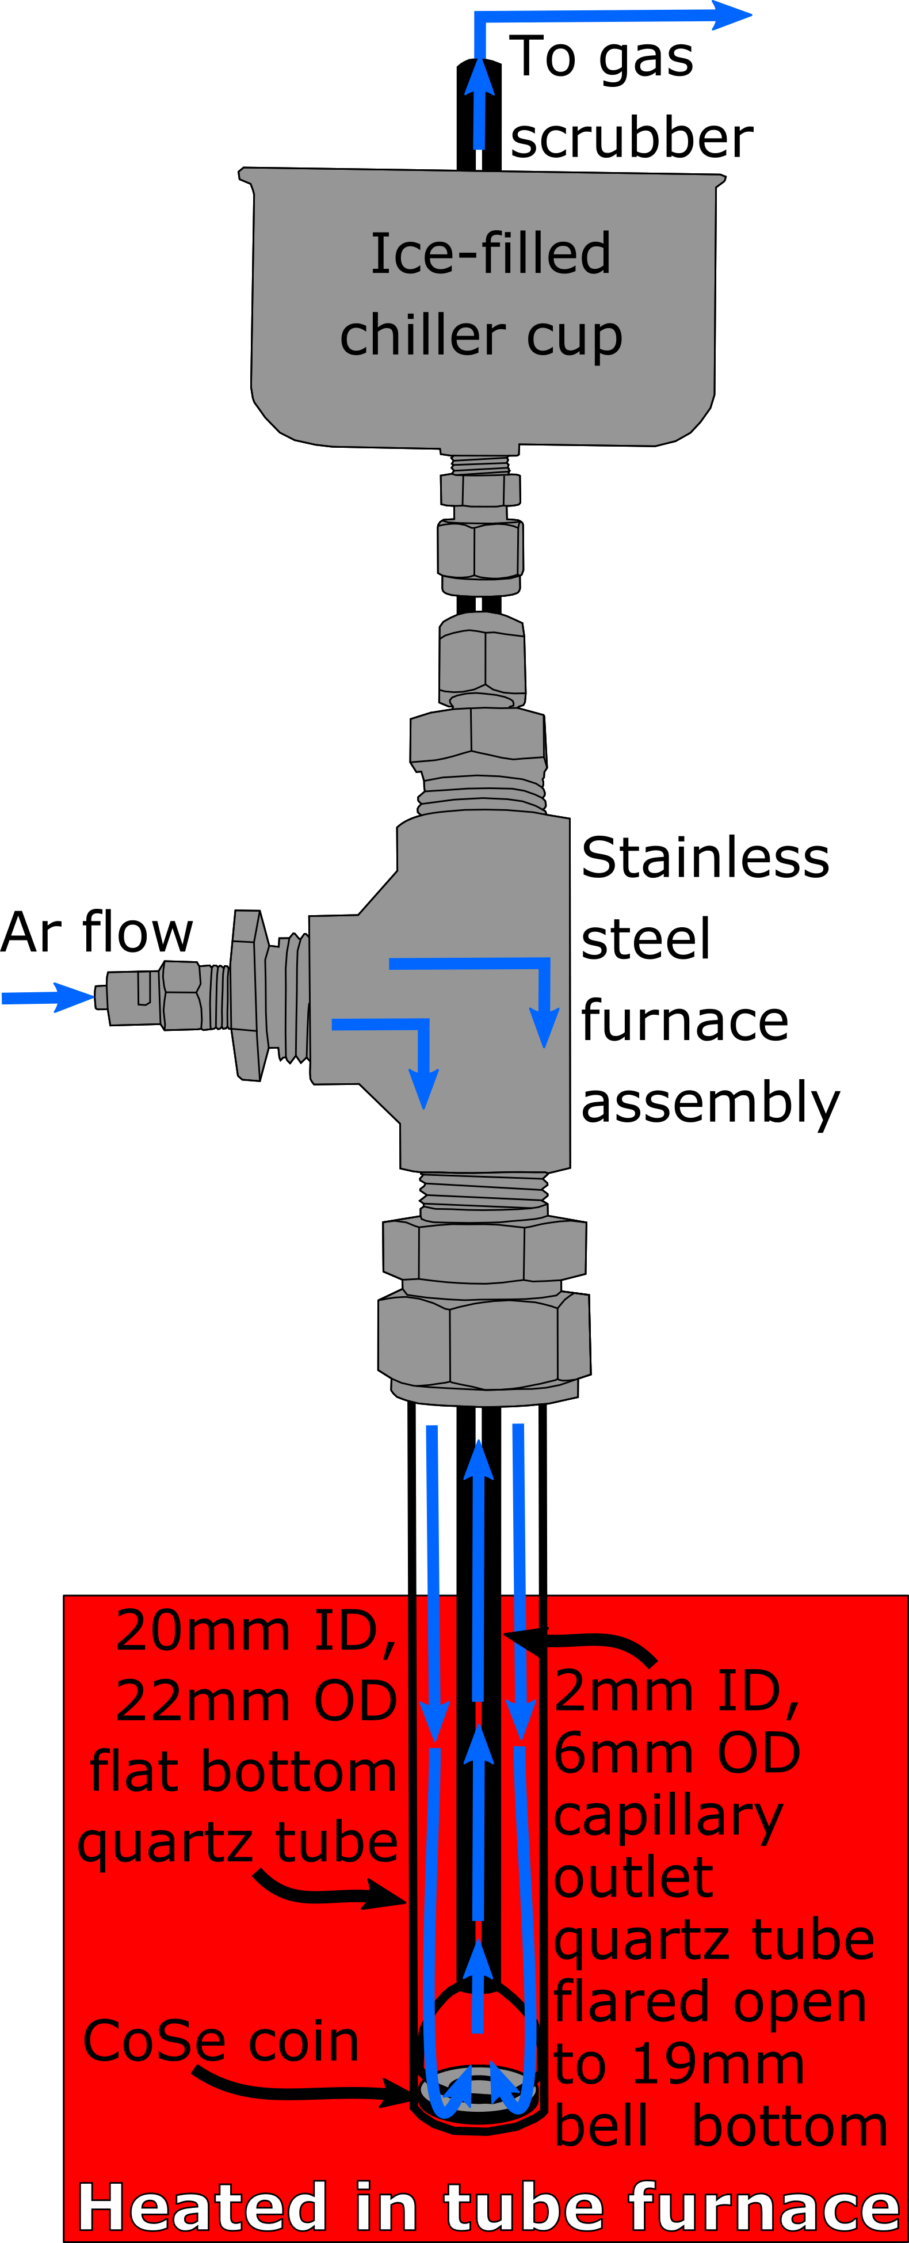
Figure 1. Vertical tube furnace assembly used for CoSe coin target production and radiobromine dry distillation.
Cyclotron production of radiobromine
Radiobromine was produced using a PETtrace cyclotron (GE Healthcare) through proton irradiation of CoSe coins. The back of the coin was directly water cooled, as shown in Figure 2. The CoSe targets were irradiated with 16 MeV protons at intensities up to 50μA. Following irradiation, the radioactivity in the target was quantified using a calibrated high purity germanium gamma ray spectrometer (HPGe, Canberra Industries).

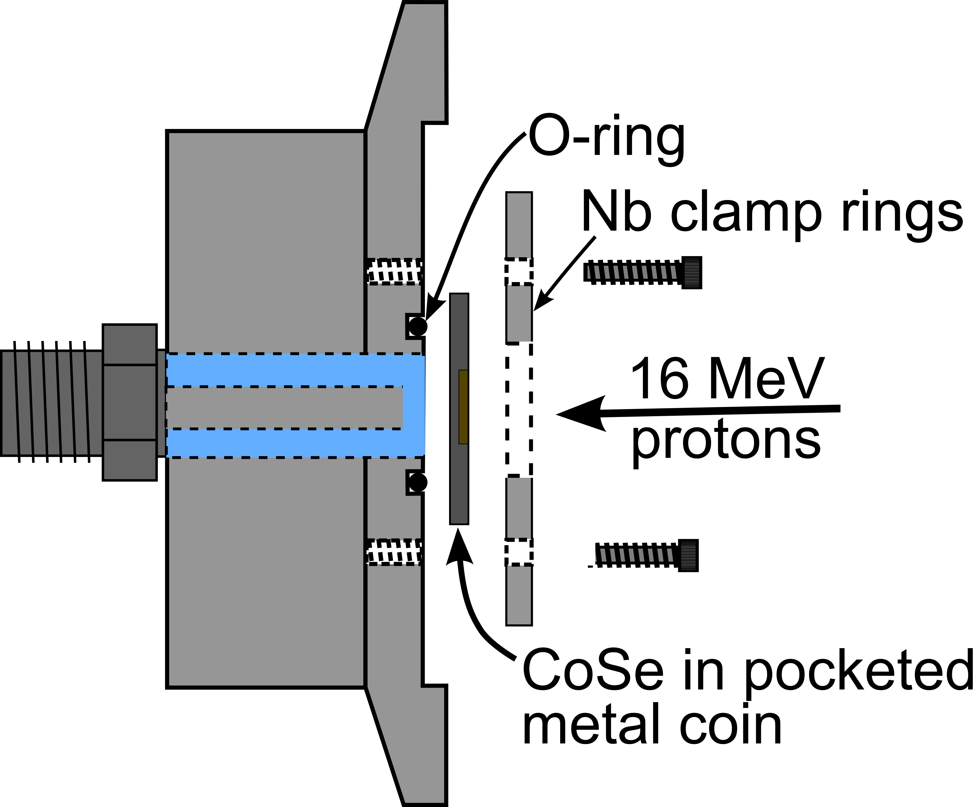
Figure 2. Cyclotron target assembly used for radiobromine production through the irradiation of CoSe coin targets.

Radiochemical isolation of radiobromine
The radiobromine was isolated from the CoSe coin by dry distillation using the vertical tube furnace assembly shown in Figure 1. Collimated radiation detectors assessed the radioactivity in the CoSe coin and at various points outside the furnace along the outlet capillary tube as a function of distillation time. The assembly was purged with 200 mL/min Ar flow and lowered into a furnace preheated to 950 - 1000 °C. Continuous 40 - 200 mL/min argon flow through the assembly was bubbled through a series of water and sodium hydroxide gas scrubbers. Following distillation, the assembly was raised from the furnace and immediately quenched in water. After disassembly, the distribution of radiobromine deposition along the capillary outlet tube was qualitatively measured using a collimated radiation detector. Using a cork and syringe, warm water (500 μL) was pipetted backwards up the capillary outlet tube to remove deposited radiobromine. Total dry distillation radiochemical yield was assessed by HPGe spectroscopy, and trace metal contaminants of the final aqueous radiobromine solution were quantified using microwave plasma atomic emission spectrometry (MP-AES, Agilent MP4200).

Results and Discussion
Synthesis of CoSe target material:
Reclaimed yields of CoSe from the sintering process were (93±4)% (n=9) in a single brittle, bronze-colored, irregularly-shaped pellet. Further characterization of the physical properties of the produced CoSe are ongoing.

Production of CoSe coin targets:
Based on calculations using SRIM, 250 mg of CoSe deposited in the 9.5 mm diameter pocket would be sufficient to degrade the beam energy to ~8 MeV, making optimal energetic use of the ⁸⁰Se(p,n)^{80m}Br excitation function [8]. After the hot pressing process, CoSe wetted the coin, filling the 1 mm deep pocket to a depth of 0.5 mm (Figure 3). (95±4)% (n=3) of the CoSe mass found adhered to the backing, with lost material found in a bronze/red/black deposit on the outlet capillary tube. Similar results were observed using niobium and cobalt backings.

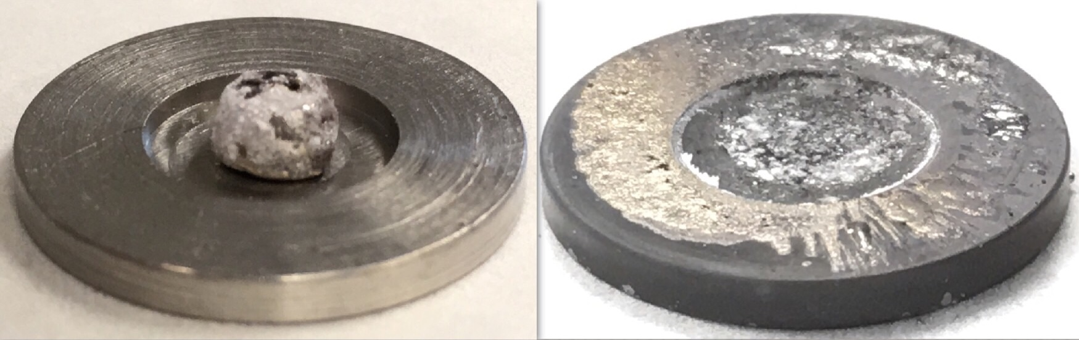
Figure 3. Co⁸⁰Se on a Nb coin target before and after hot pressing of Co⁸⁰Se.

Cyclotron production of radiobromine
Initial irradiations of CoSe coin targets were performed with a 50 μm Nb cover foil between the target and Nb clamp ring. While irradiations with up to 30 μA showed no visible change to the target or cover foil, irradiation with 40 μA of protons significantly warped the Nb cover foil, left a foil-shaped discoloration on the coin rim and reduced radiobromine yields. With no cover foil, no visible change to the target was observed under all irradiation conditions investigated, up to 50 μA irradiation intensity. Radionuclide production yields are shown in Table 1. The ^{80m}Br cyclotron yield was measured as a function of proton irradiation current using a single Co⁸⁰Se target, with n = 2 irradiations each at 10, 20, 30, and 40 μA, shown in Figure 4.

End of bombardment yield
[MBq∙μA⁻¹∙h⁻¹]
 | ^{80m}Br | ⁷⁶Br | ⁷⁷Br | ⁸²Br | ⁵⁸Co
Co^{nat}Se | 70 ± 10 | 11 ± 1 | 3.2 ± 0.4 | 2.2 ± 0.3 | 0.08 ± 0.01
Co⁸⁰Se | 100 ± 10 | ~8 ∙ 10⁻³ | ~3 ∙ 10⁻³ | ~1 ∙ 10⁻³ | 0.10 ± 0.04
Table 1. Radionuclide production yields for Co^{nat}Se and Co⁸⁰Se coin targets.

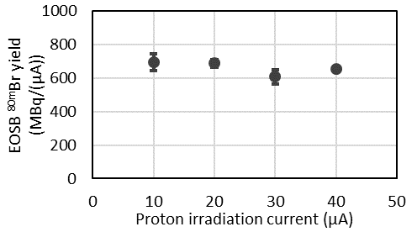
Figure 4. End of saturated bombardment (EOSB) ^{80m}Br yield from proton irradiation of Co⁸⁰Se as a function of irradiation current.

Radiochemical isolation of radiobromine
The proton irradiation of Cu₂Se and NiSe targets results in the co-production of GBq quantities of ⁶³Zn and ⁶⁰Cu, respectively. The proton irradiation of CoSe is free from these radioimpurities, making it much better suited for the production of the relatively short-lived ^{80m}Br. The distillation of radiobromine was fast, with (92 ± 7)% (n=5) of the bromine activity diffusing out of the target in < 20 min. Visible cobalt and selenium deposits were observed along the outlet capillary tube near the bottom of the stainless steel furnace assembly. The distribution of the distilled radiobromine activity found along the outlet capillary tube and gas scrubber solutions was highly variable between individual distillations. Optimization of furnace temperature, argon flow rate, and radiobromine trapping and reclamation methods are ongoing. The CoSe coin targets are exceptionally reusable through the irradiation/distillation process. After nine irradiations and one distillation, the Co⁸⁰Se on Nb target shown in Figure 5 lost 1.4% of its initial Co⁸⁰Se mass.

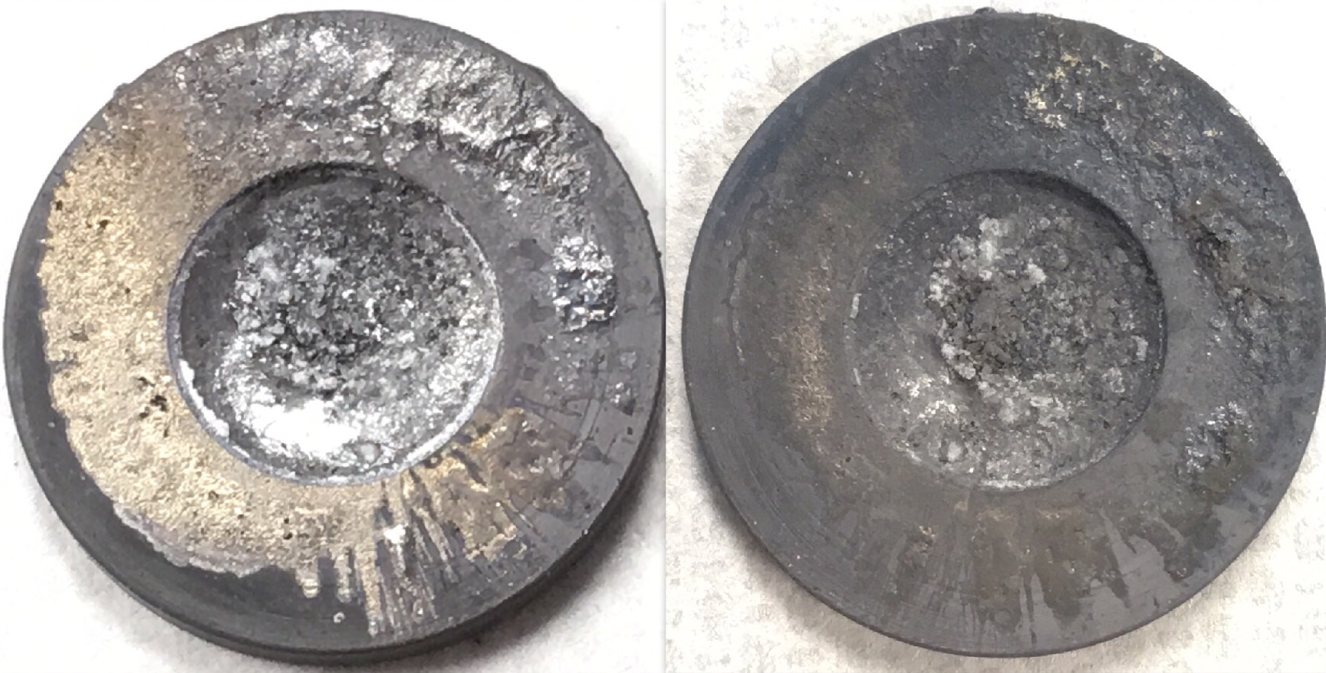
Figure 5. Co⁸⁰SeOnNb coin target before and after nine irradiations with up to 40 μA protons and one radiobromine distillation.

Summary and Conclusion
This work describes new methods for the production of radionuclidically pure ^{80m}Br. These methods can be used to produce ~5 GBq quantities of ⁷⁷Br and ~10 GBq quantities of ⁷⁶Br. The new target compound, CoSe, was found to provide fewer high-dose radioimpurities and excellent reusability for subsequent irradiation / distillations. Isolation of ^{80m}Br is readily accomplished from this target within 30 minutes of end of bombardment. Optimization of the distillation parameters to maximize the radiobromine recovery in a small volume of water is ongoing.

References
- RW Howell et al., Int J Radiat Biol 84: 959-975 (2008).
- I Saikia et al., Chem Rev 116: 6837-7042 (2016).
- ER Desombre et al., Cancer Res 48: 899-906 (1988).
- W Vaalburg et al., Int J Appl Radiat Isot 36: 961-964 (1985).
- L Tang, Q J Nucl Med Mol Imaging 52: 121-133 (2008).
- HE Hassan et al., Radiochim Acta 105: 841-850 (2017).
- K Breunig et al., Radiochim Acta 103: 397-402 (2015).
- I Spahn et al., Radiochim Acta 98: 749-755 (2010).

Acknowledgements
This work was supported by the United States Department of Energy Office of Science grant DE-SC0017919.

