Radiolysis in a Water-Filled Heavy Ion Target
H. K. Clause^{a,1}, E. P. Abelª, G. W. Severinª

ªNational Superconducting Cyclotron Laboratory at Michigan State University, East Lansing, MI 48823

Introduction

Currently at the National Superconducting Cyclotron Laboratory (NSCL), reactions of heavy ion beams produce radionuclides that would be valuable in research studies involving biological, chemical, physical, and medicinal processes.¹ However, only a small portion of the produced radionuclides are utilized, leaving a majority of the beam to be deposited into a solid tungsten target to decay away.² By replacing the solid target with a water-filled beam blocker and adding a water system, there is a possibility to harvest radionuclides from the primary beam to use for applications in many research fields.

The water-filled beam blocker is made out of a titanium alloy (Ti6Al4V) which is known for its resistance to corrosion that is expected due to the irradiation of water. When water is irradiated, energy is deposited along the radiation track causing radiolysis, or the break-up of water molecules. This results in the formation of free radicals and other molecular species including ∙OH, ∙H, H⁺, OH⁻, H₂, and H₂O₂. As irradiation continues, the radiolysis tracks form closer together which allow for the recombination of these species. However, H₂O₂ does not recombine and is distributed throughout the system which can be damaging to the system and must be mitigated. In addition, the production of H₂ gas dissolved in the water could lead to a buildup of pressure which must also be kept to moderation.³

An experiment was designed to test the stability and resistivity of the chosen titanium alloy under the conditions caused by irradiation while also having an opportunity to study the state of the water system under these conditions.
Material and Methods

In this experiment, a thin (700 μm) disk of Ti6Al4V was placed in a target (Figure 1) made of high-density polyethylene which is also known for chemical resistance.⁴ This target window was a replacement for the water-filled beam blocker to ensure that the material will be sufficient to move forward with future experimentation. The titanium window was irradiated by a ⁴⁰Ca²⁰⁺ beam with 140 MeV/u energy at both 1 W and 3 W of beam power.
Figure 1: A drawing of the titanium target and housing used in the experiment.
In addition to the titanium window, an attached water system (Figure 2) that included probes and sensors that were plumbed together was used to continuously measure and record the state of the water. A conductivity probe and pH probe were used to detect degradation products and the formation of radiolysis products, respectively. A hydrogen peroxide degrader made of platinized titanium mesh was used to break down H₂O₂ into H₂O and O₂, followed by a dissolved oxygen probe to measure this process. The system also included membrane contactors used to separate the aqueous and gas phases, followed by a hydrogen gas sensor to measure the amount of hydrogen produced during radiolysis.
Figure 2: A schematic of the harvesting equipment used in the experiment. Green lines depict the flow of water, with red showing the flow of gas.
To determine the location of irradiation on the titanium window, an autoradiograph along with an optical image of the disk was performed. Comparison of these analytical techniques were used to demonstrate similar alignment of the beam spot. Further characterization of this area can be achieved by analysis through scanning-electron microscopy (SEM) along with energy-dispersive x-ray spectroscopy (EDS).^{5,6}

Results and Conclusion

During the experiment, each sensor within the water system was measuring and recording data. The information collected was used to understand the state of the water and atmospheric re-equilibration during irradiation. The pH of the system was constant around 5.9 and there was little change in dissolved oxygen within the system, both results most likely due to re-equilibration of carbon dioxide from the atmosphere. There was an increase in conductivity that was dependent on the beam power which suggests a possibility of degradation of the titanium surface of the window.
As a major product of radiolysis, the concentration of hydrogen gas produced during the experiment was measured (Figure 3). During the lower intensity of beam, the average concentration of hydrogen was around 130 ppm. That concentration increased to an average of 420 ppm at the higher beam intensity. Radiolysis production was also observed to be dependent on beam power at a production rate of approximately 3.01 μmol/W.³

In order to detect the presence and activity of isotopes trapped in various components of the target and water system, gamma spectrometry was used. These results can provide more information about any degradation to the surface of the titanium disk to be used in tandem with other testing.
Figure 3: Depiction of the hydrogen sensor reading. Highlighted in orange represents the period of time where the beam power was 1 W, with the remainder of the data at a beam power of 3 W. Each dip in the graph to zero occurred because a Faraday cup was inserted during that time, obstructing the beam.


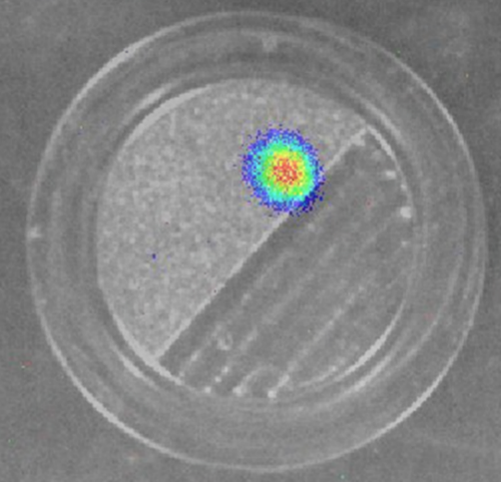
After visual observation of the titanium disk, discoloration was seen due to irradiation. Results from the autoradiograph and optical image of the disk demonstrate similar alignment of radiation due to the beam spot (Figure 4). The optical image also overlays the visual discoloration of the window. Further analysis of the surface of the material will be completed by using SEM to compare the topography of irradiated and non-irradiated titanium alloy samples. In addition, EDS will allow for the analysis of the elemental composition of the alloy to not only confirm the structure of the alloy, but to also observe the possible existence of an oxide layer.
Figure 4: Autoradiograph image (left) and optical image (right) demonstrating the placement of the beam spot. The arrows denote the top of the window as placed into the target.

The results from each sensor along with information learned from the material analysis will be used to determine the stability and corrosion resistivity of the Ti6Al4V alloy chosen and to determine if this material is sufficient to proceed with for future experimentation.

References
1. Severin, G.; et al. Report. 2017.
2. National Superconducting Cyclotron Laboratory Homepage. https://www.nscl.msu.edu
3. Meesungnoen, J.; Jay-Gerin, J. P. J. Phys. Chem. A., 109, pp. 6406 – 6419. 2005.
4. Gonzalez, J. E. G.; Mirza-Rosca, J. C.; J. Electroanal. Chem, 471, pp. 109 – 115. 1999.
5. Joy, D. C. Materials Science and Technology, 1st ed,; Wiley-VCH Verlag GmbH & Co.: TN; pp. 222 – 248. 2006
6. Shindo, D.; Oikawa, T. Analytical Electron Microscopy for Materials Science; Springer: Tokyo; pp. 81 – 102. 2002.

Acknowledgements
We would like to thank Mathias Steiner, Frederique Pellemoine, Nicolas Dronchi, Jason Hart, and Marina Llewellyn for assistance during the experiment and data collection. This research was supported by Michigan State University and the National Superconducting Cyclotron Laboratory NSF-1565546.

