17th International Workshop on Targetry and Target Chemistry – presentation abstract submission
Research on production of ⁹⁷Ru with the use of Radionuclide Yield Calculator at ARRONAX
Mateusz Sitarz^{1,2}, Etienne Nigron³, Arnaud Guertin³, Férid Haddad¹

¹ GIP ARRONAX, France, ² University of Warsaw, Poland, ³ SUBATECH laboratory – CNRS/IN2P3, IMT Atlantique, Nantes University

Introduction
Many radioisotopes have features convenient for the nuclear medicine and so they are commonly used for diagnostics or therapy. A lot of them can be produced with the use of the cyclotron, during the irradiation of the target with protons, deuterons or alpha particle beams. These irradiations use very high beam intensities and thick targets in order to maximize the production of activity that will be later used in the medical field.
One of such radioisotope is ⁹⁷Ru which can be used for both diagnostic and therapeutic purposes due to its favorable physical and chemical properties (T_{1/2} = 2.9 d, decay 100% EC with no β+ to contribute to the dose, several degrees of oxidation, more stable compounds compared to the conventional ^{99m}Tc).

Aim
During the irradiation, the medical radioisotope is formed via the nuclear reaction with a certain probability (cross-section) which is the most important factor when planning the production. This probability depends on the target material as well as type and energy of the projectile. In this work, we focus on the ^{nat}Mo(α,x)⁹⁷Ru reaction in order to extend the available cross-section data above 40 MeV, in coherence with alpha beam available at our facility.
Our aim was also to develop small, user friendly software that could calculate the production yield of ⁹⁷Ru (and any other radioisotope) on the thick target, based on the cross-section data, the stopping power of projectile, the target chemical form and the irradiation parameters. This software is made available to the community on our web-site.

Materials and methods
To measure the cross-section of the ^{nat}Mo(α,x)⁹⁷Ru reaction, we performed the irradiation of ^{nat}Mo stack foils with the α-beam of 67.4 MeV. The energy straggling in the last foil was calculated to be 0.75 MeV. The irradiated foils were measured via gamma-ray spectroscopy techniques.
Using python programming language, we developed the Radionuclide Yield Calculator (RYC), software with GUI (see Fig. 1) that can run on Windows. It uses SRIM module to calculate the stopping-power. After providing the basic irradiation parameters (like projectile type, beam current, target chemical form, radioactive product) the user can easily:
- fit different functions to the cross-section data
- download the cross-section for the selected production route from TENDL data-base
- calculate production yield and the activity at the end of bombardment
- find the possible radioactive contaminants

Results and discussion
We have measured the cross-section for the α-induced reactions on ^{nat}Mo in the energy range 67 – 42 MeV (see Fig. 2). Using RYC, we were able to estimate that the irradiation of 250 µm ^{nat}Mo with 65 MeV α-beam will yield around 10 MBq/µAh (0.27 mCi/µAh) of ⁹⁷Ru. Most importantly, the use of such high energy prevents the formation of long-lived contaminant ¹⁰³Ru (T_{1/2} = 39.35 d). Although the yield of 0.27 mCi/µAh is lower compared to the ¹⁰³Rh(p,x)⁹⁷Ru reaction with around 1.3 mCi/µAh, it allows to use the cheaper target with better thermal properties. Therefore the method to produce ⁹⁷Ru via ^{nat}Mo(α,x) might be considered in certain cases.
We have also verified that RYC can quickly calculate production yield and activity of radioisotopes based on the cross-section data and irradiation parameters. It is free software available on our website (http://www.cyclotron-nantes.fr/spip.php?article373) which is still being developed and improved at the GIP ARRONAX.

Acknowledgements
The cyclotron Arronax is supported by CNRS, Inserm, INCa, the Nantes University, the Regional Council of Pays de la Loire, local authorities, the French government and the European Union. This work has been, in part, supported by a grant from the French National Agency for Research called "Investissements d'Avenir", Equipex Arronax-Plus noANR-11-EQPX-0004 and Labex IRON noANR-11-LABX-18-01. The discussions with Jerzy Jastrzębski as well as the support of the French Government PhD scholarship are acknowledged.
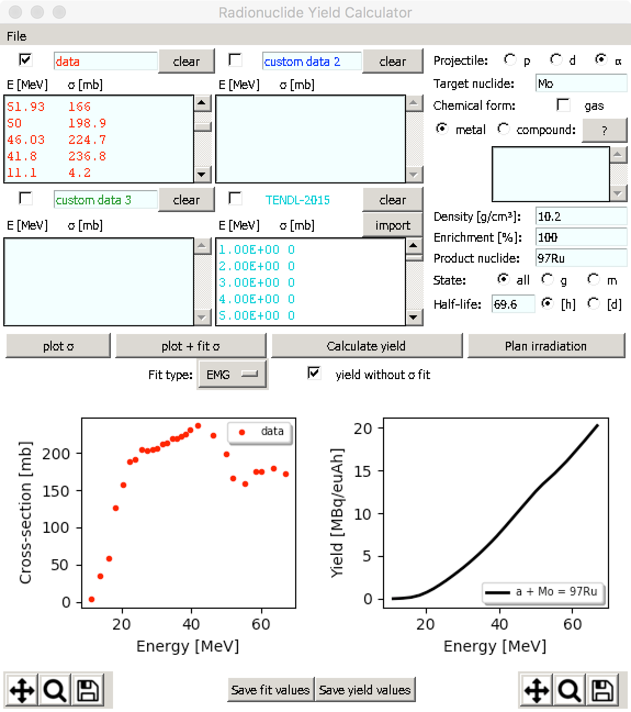
Fig. 1. RYC interface layout

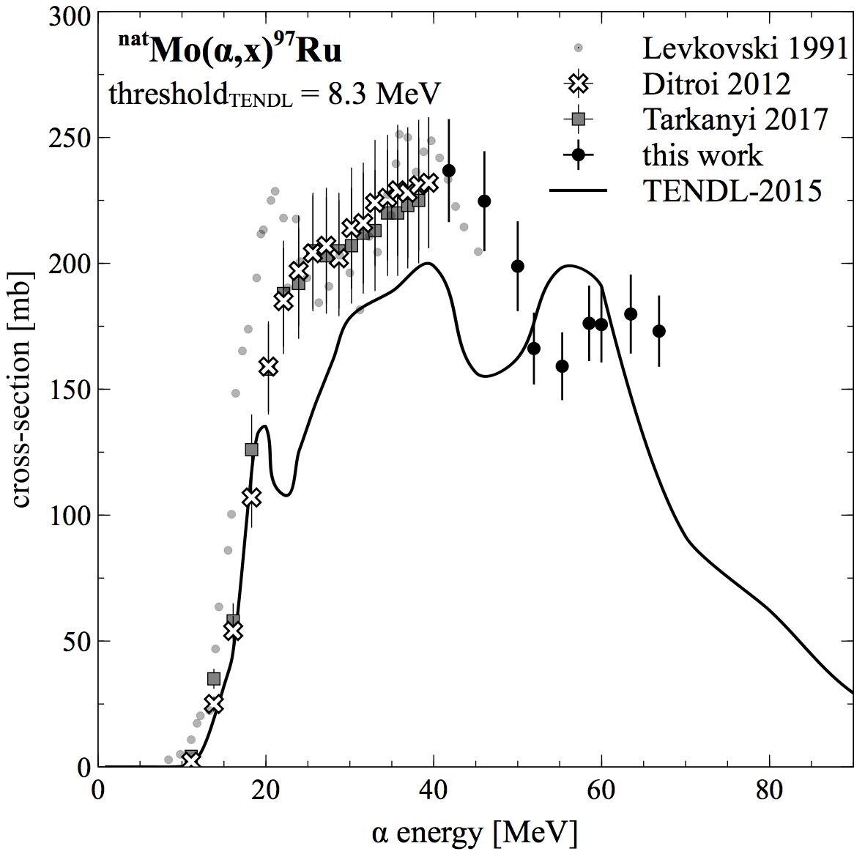
Fig. 2. ^{nat}Mo(α,x)⁹⁷Ru cross-section measured at the GIP ARRONAX in comparison to other experimental points and TENDL data-base

