Scaling up Ac-225 production at Brookhaven Linac Isotope Producer using multi target Thorium target stack
D. Medvedev^{1a}, J. Fitzsimmonsª, J. Cooley^{b}, S. Kurczakª, L. Mausnerª, C. S. Cutlerª, P. Pileª,
F. Nortier^{b}, K. John^{b}
ªCollider-Accelerator Department, Brookhaven National Laboratory, Upton, NY, USA
^{b}Los Alamos National Laboratory, Los Alamos, NM, USA

Introduction
The excitation function for the ²³²Th(p,2p6n)²²⁵Ac reaction increases with proton energy and reaches 14-17 mb when proton energies are above 160 MeV. Hence, to produce more than 1 Curie of Ac-225 a massive target is required. Brookhaven National Laboratory (BNL) is part of the Tri-Lab effort between BNL, ORNL, and LANL that is engaged in development of a Thorium target to produce multi-Curie amounts of Ac-225. BNL operates a 200 MeV Linac capable of producing currents up to 178 µA (165 µA in routine operation). Current design of the target station at Brookhaven Linac Isotope Producer (BLIP) can accommodate five massive Th targets (~3.5 g/cm² each) positioned one after another and separated by 5 mm wide cooling channels. The SRIM calculated entrance energy on the target varies from 192 (upstream, position 1) to 138 MeV (downstream, position 5). The power deposition, calculated for 165 µA reaches 1.68 kW for the most downstream target (Table 1).
Target  pos. | 1 | 2 | 3 | 4 | 5
E_{in},  MeV | 191.9 | 179.6 | 166.7 | 153.3 | 138.4
Power, kW | 1.35 | 1.41 | 1.48 | 1.57 | 1.68
Table 1. Incident energy and power deposition in Th targets (~3.5 g/cm²) simultaneously irradiated at BLIP at 165 µA.
While extensive thermal modeling on the targets performance can be carried out, it is equally critical carry out a test experiment to evaluate the target survivability in the beam. Initially, a conservative approach of the lowest power deposition should be considered. In this work we report results of test irradiations of thick Th target with power deposition of 1.35 kW. The aim was to ensure target’s survivability in the beam and gain information on the modifications for target design, which would allow effortless removal of the Th puck from the cladding.

Material and Methods
The target was comprised of a Th puck encapsulated in the Inconel cladding. It was manufactured as follows: a 0.012 inch thick Inconel window was EB-welded to the Inconel ring (d=2.75 inch) at EB industries (Farmingdale, NY). The welded assembly along with the other 0.012 inch window was shipped to LANL where the encapsulation of Th was carried out at Sigma Facilities. For that a 3 mm thick Th puck was sectioned into three sectors, 60⁰ each, packed into the cladding and the second window was EB welded. The target was further filled with Helium gas through small holes located in the sides of the ring. The holes were further welded shut, thus, sealing the Th puck.
The target was shipped back to BNL where it was irradiated. Originally, it was planned to carry out irradiation at 165 μA, but due to technical difficulties only 128 μA was available from Linac. Hence, the incident energy on the target was tailored to 133 MeV by degradation to ensure that the power deposition was equivalent to target at position 1 (Table 1).
The irradiation was carried out for 4 hours with a Gaussian shaped beam (sigma=5.1 mm) rastered at r = 5.5 mm (1 pulse) and at r=12 mm (4 pulses), accumulating a total charge of 522 μA-h.
Upon completion the target was transported to a hot cell where it was visually inspected. The window was cut open to remove the Th material.
Calculations of production yields of Ac-225 and Ac-227 in the five target stack at BLIP was carried out using activation equation:
Activity =[beam current]×[atom density]×[target thickness]×[cross section]×[saturation factor]. All parameters were converted to SI units for calculations. The cross section data was compiled from several sources: Ermolaev et al¹, Weidner et al², Engle et al³, Griswold et al⁴. The data from these sources was combined on one plot and fitted with sigmoidal function using Sigma Plot software (Version 12.5, Systat Software, Inc). The numerical values returned by these σ(E) functions were used for activity calculations.

Results
After irradiation the target appeared pristine with no heat marks visible on the outside of the capsule. Upon front window removal, slight discoloration was noticed on the inner part of the front window resembling the sectoring pattern of the Th puck, where thermal conductivity was compromised. The target appeared to be stuck in the ring and did not come out upon flipping it upside down. The Th material was eventually removed sector by sector by applying substantial force from the other window. In fact we believe that sectioning the target was critical in this case for the successful removal of Th (Figure 1). No fusion of Th to the other window was observed.
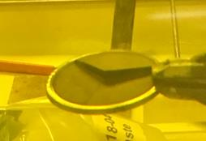
Figure 1. A photograph of Th material inside the can after irradiation
Irradiation of arrays of massive Th targets at BLIP opens up the possibility of multi-Curie production of Ac-225. Several scenarios are summarized in Figure 2.
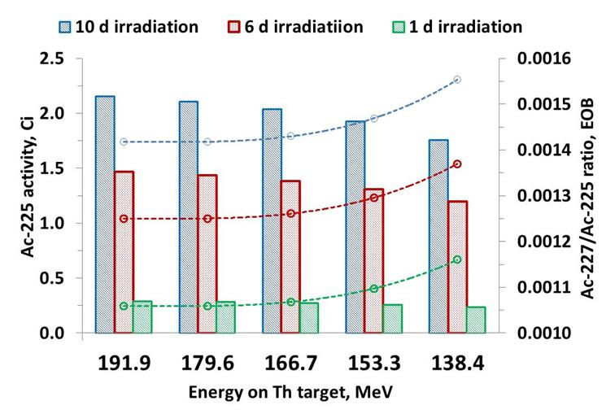
Figure 2. Predicted quantity and level of Ac-227 impurity in Ac-225, produced in a 5 target stack at BLIP
To achieve the optimum return per µA, the targets are irradiated for one half-life of the desired radioisotope. For the 10 days irradiation at 165 μA close to 10 Ci of Ac-225 at EOB is expected, with about 2 Ci per target (Figure 2). However, the longer lived Ac-227 (T_{1/2}=21.772 y) impurity would be at the highest level. As expected, in a shorter (1 day) irradiation the longer lived impurity would be at the lowest level. However, only 1 Ci of Ac-225 would be produced in this case in all 5 targets (Figure 2). The practical parameters for irradiation will be driven by the isotope demand as well as the ability of chemical processing to handle large targets.
Conclusion
Irradiation test of a massive Th target at BLIP was carried out at the most conservative condition and is the first step in such testing. It should be noted that the present test was carried out in the best cooling environment: the water flow was distributed between three cooling channels (5 mm each): upstream of the degrader, between the degrader and the target, and downstream of the target. With 5 targets in the stack the number of such water channels will increase to 6 or even 7, which would worsen the cooling. Future efforts will be focused on target evaluation under those more severe conditions.
References
1. S. V. Ermolaev, B. L. Zhuikov, V. M. Kokhanyuk, V. L. Matushko, S. N. Kalmykov, R. A. Aliev, I. G. Tananaev and B. F. Myasoedov, Radiochim. Acta 100 (4), 223-229 (2012).
2. J. W. Weidner, S. G. Mashnik, K. D. John, F. Hemez, B. Ballard, H. Bach, E. R. Birnbaum, L. J. Bitteker, A. Couture, D. Dry, M. E. Fassbender, M. S. Gulley, K. R. Jackman, J. L. Ullmann, L. E. Wolfsberg and F. M. Nortier, Applied Radiation and Isotopes 70 (11), 2602-2607 (2012).
3. J. W. Engle, J. W. Weidner, B. D. Ballard, M. E. Fassbender, L. A. Hudston, K. R. Jackman, D. E. Dry, L. E. Wolfsberg, L. J. Bitteker, J. L. Ullmann, M. S. Gulley, C. Pillai, G. Goff, E. R. Birnbaum, K. D. John, S. G. Mashnik and F. M. Nortier, Radiochim. Acta 102 (7), 569-581 (2014).
4. J. R. Griswold, D. G. Medvedev, J. W. Engle, R. Copping, J. M. Fitzsimmons, V. Radchenko, J. C. Cooley, M. E. Fassbender, D. L. Denton, K. E. Murphy, A. C. Owens, E. R. Birnbaum, K. D. John, F. M. Nortier, D. W. Stracener, L. H. Heilbronn, L. F. Mausner and S. Mirzadeh, Applied Radiation and Isotopes 118, 366-374 (2016).
Acknowledgements
Work supported by Brookhaven Science Associates, LLC under Contract No. DE-SC0012704 with the U.S. Department of Energy. U.S. DOE Office of Nuclear Physics Isotope Program is acknowledged for funding.

