Indigenous development of Semi-Automated Solid target irradiation assembly compatible with PETtrace-800
Kanchan Kushwaha^{a, b,1}, Pravind Malethaª, Sunil Kamble^{c}, Jyothish Babu^{c}, Tejindar Singh Sabharwal^{c}, Kavindra Pathak^{c}, Manish Kumar^{c}, Nand Kishore Prasad^{c}, Tushar Kanti Saha^{c}, Sharmila Banerjee ^{a, b}

ªRadiation Medicine Centre, BARC, TMH Annexe, Parel, Mumbai 400012, India
^{b}Homi Bhabha National Institute, BARC, Anushakti Nagar, Mumbai 400094, India
^{c}Technical Physics Division, BARC, Trombay, Mumbai 400085, India

Introduction
⁶⁴Cu has been known to be an effective radioisotope particularly in PET imaging studies. A solid target assembly for the production of ⁶⁴Cu via ⁶⁴Ni (p, n)⁶⁴Cu has been developed in-house in order to extend the utilization of the existing PETtrace-800 facility.
Materials and Method
Considering the compatibility requirements, the design was developed (fig-1). 16.5 MeV proton beam is allowed to sequentially incident on Havar foil, attenuation foil and ⁶⁴Ni layer electroplated on base plate. Helium gas and water were used for heat dissipation (fig-2, table-1). The assembly body is made of aluminium and copper. Removal of base plate is carried out using semi-automation procedure. Stepper motor moves the base plate in horizontal direction and drops it in lead pot through a pipe, which will be carried out manually for chemical processing.

Fig-1 Schematic of solid target assembly
 | Material | Working | Dimension  (Diameter, thickness in mm) | Proton energy  Attenuation (MeV),  heat load (W)at 25 μA
Havar | (Co, Cr, Ni, W, Mo, Mn, C, Fe) | To prevent  Vacuum | 27, 0.025 | (16.5-16), 12.5
Attenuation  Foil | Al | To attenuate  proton energy | 20, 0.5 | (16-12), 100
Target layer | ⁶⁴Ni | Target material | 8, 0.120 | (12-9), 75
Base plate | Gold plated Cu | To support ⁶⁴Ni layer | 25, 2 | (9-0), 225

Table-1 Dimension and Heat load of different part of solid target assembly
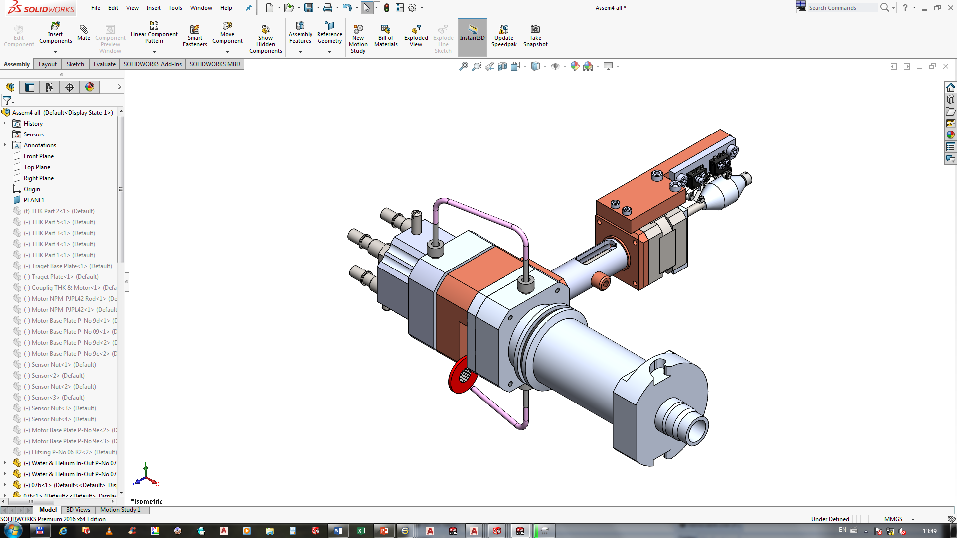
Fig-1 Solid target assembly

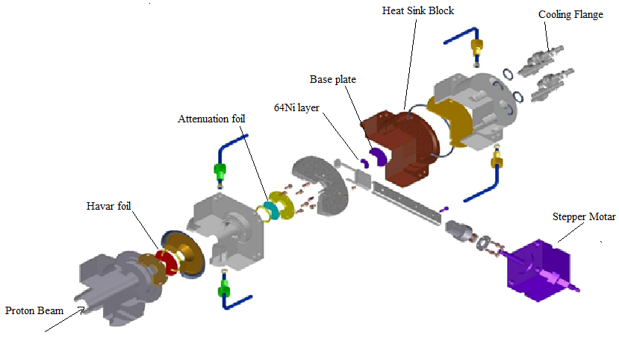
Fig-2 Schematic of solid target assembly

Results and Conclusions The use of Solid target assembly as described has been successfully demonstrated in the PETtrace-800 facility using proton beam of 2 µA for 30 m¹. Further studies using higher beam current are under progress.
Reference
1)Production of ⁶⁴Cu, using indigenously developed solid target assembly in Medical Cyclotron Facility in Radiation Medicine Centre (ESRR’18 – 19th Eur. Symp. Radiopharmacy Radiopharm. Apr 5-8,2018)

