Production and characterization of titanium-45
Ivis Chaple¹, Adriana V. Massicano¹, Brian Wright¹, Eszter Boros², Suzanne E. Lapi^{1,}

¹Department of Radiology, University of Alabama at Birmingham
²Department of Chemistry, Stony Brook University

Introduction
The development of new agents for Positron Emission Tomography (PET) allows investigators to monitor biological parameters in research studies and patient treatment. Titanium-45 (t_{1/2} = 3.08 h) has been proposed as a PET imaging radioisotope based on its promising nuclear and chemical properties, including its decay characteristics of 85% positron emission with E_{β+max} = 1.04 MeV. The three-hour half-life allows for longer imaging times than the widely used ⁶⁸Ga, and may have advantages for imaging with peptide-based agents. This isotope can also be produced by proton bombardment of scandium, which is monoisotopic and hence has economic advantages. This study focuses on the production and purification of ⁴⁵Ti via the ⁴⁵Sc(p,n)⁴⁵Ti reaction using natural scandium foils. In this work, we aim to optimize our separation technique, yielding quantities of high purity ⁴⁵Ti for radiolabeling studies.

Material and Methods
The TR-24 cyclotron at the University of Alabama was used for all irradiations. Natural scandium foils (Alfa Aesar, 0.25 mm) purchased from Fisher Scientific. All other materials were purchased from Fisher Scientific unless stated otherwise.

Production of ⁴⁵Ti
Natural scandium foils were placed into a 0.3 mm deep divot inside a 1 mm thick niobium coin and irradiated with a current of 5 µA and 18 MeV protons for a duration of up to 25 minutes. To avoid the production of the long-lived ⁴⁴Ti contaminant via the ⁴⁵Sc(p,2n)⁴⁴Ti reaction, proton energies of less than 16 MeV are required, thus, a 0.75 mm thick aluminum degrader was used to attenuate the energy of the incoming protons from 18 MeV to ~13 MeV with the proton energy exiting the foil into the niobium coin backing at ~11 MeV. Theoretical yield for the production of ⁴⁵Ti at a bombardment time of 25 minutes was 28.71 mCi. With these parameters, production was expected to be radiochemically pure with no co-production of radiocontaminants.

Separation of ⁴⁵Ti and ⁴⁵Sc
Various separation methods were tested including cation exchange resins such as AG50x8 and followed by variations of acid eluents. Our optimal technique made use of a separation method using a hydroxamate resin made in house following a procedure adapted from Holland et al (1). The scandium foil was dissolved in 6M HCl, diluted to 2M and then added to the column with an average of 175 mg of resin. Four washes of different solutions followed and the pure ⁴⁵Ti was eluted in the final wash of 4 mL. Total separation time was about 3 hours. The separation was conducted as shown in Figure 1.

FIGURE 1. Separation method used for the purification of ⁴⁵Ti.

Determination of Radiochemical and Chemical Purity
To determine the purity of the product, a high purity germanium detector (HPGe) was used for gamma spectroscopy. The main characteristic gamma peak (720 keV) was used to quantify the amount of activity produced. A Capintec, Inc. dose calibrator (CRC-25R) was also used to assay the amount of radioactivity after it was appropriately calibrated. The data was analyzed to determine if there were any radiochemical impurities. The solutions were then allowed to decay and analyzed using ICP-MS to assess the product for the amount of scandium target material and other trace metals.

Radiolabeling and Imaging Studies
Other preliminary studies were conducted including radiolabeling several metal-binding chelators. Subsequently, we also conducted PET imaging studies using a Derenzo phantom which was imaged on the UAB small animal PET scanner. For these studies, we added 100 μCi of ⁴⁵Ti in 15 mL of water which was used to fill the phantom. The total scan time was 60 minutes and the images were then compared to images produced from a ¹⁸F phantom filled with the same amount of activity and scanned for the same amount of time.

Results and Conclusion

Recovery and yields
Scandium target irradiaions yielded 24.94 ± 2.37 mCi (n=11) of ⁴⁵Ti which is in good agreement with predicted values. Our separation method allowed us an average recovery of 71.28% (n=9) of activity after decay correction. Total separation time was almost four hours which was the biggest factor impacting recovery yields.

Figure 2 shows a typical gamma spectrum after production illustrating the radiochemical purity of the product. No radiochemical contaminants were observed in the final ⁴⁵Ti fractions.

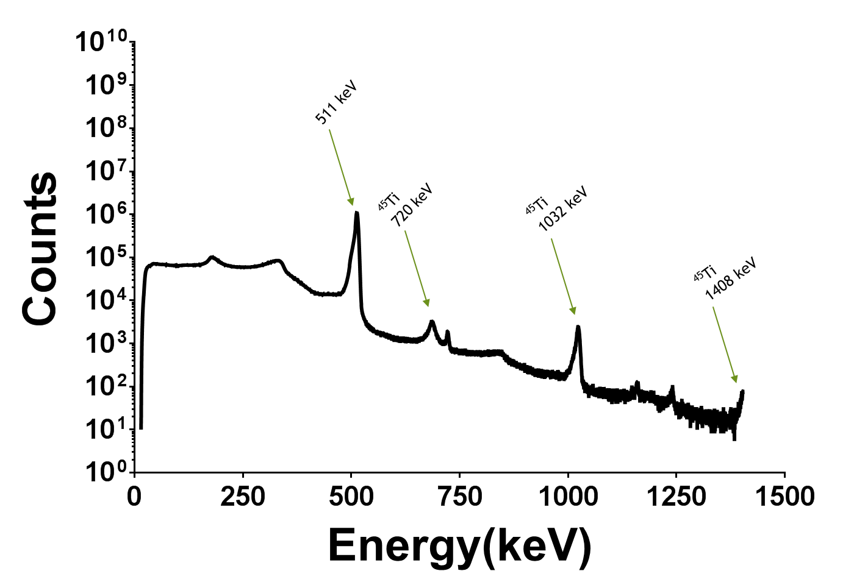
FIGURE 2. A gamma spectrum after production showing the characteristic peaks of ⁴⁵Ti.

The purity of the product after separation was tested by labeling metal-binding chelators. Commercially available and novel chelators are being examined for complexation with the produced ⁴⁵Ti. Preliminary imaging studies using a Derenzo phantom showed that ⁴⁵Ti is a promising isotope for high-resolution PET imaging. ⁴⁵Ti images were comparable in resolution to ¹⁸F, thus demonstrating the utility of ⁴⁵Ti as a PET imaging radionuclide. Figure 3 shows the results of the PET scans.

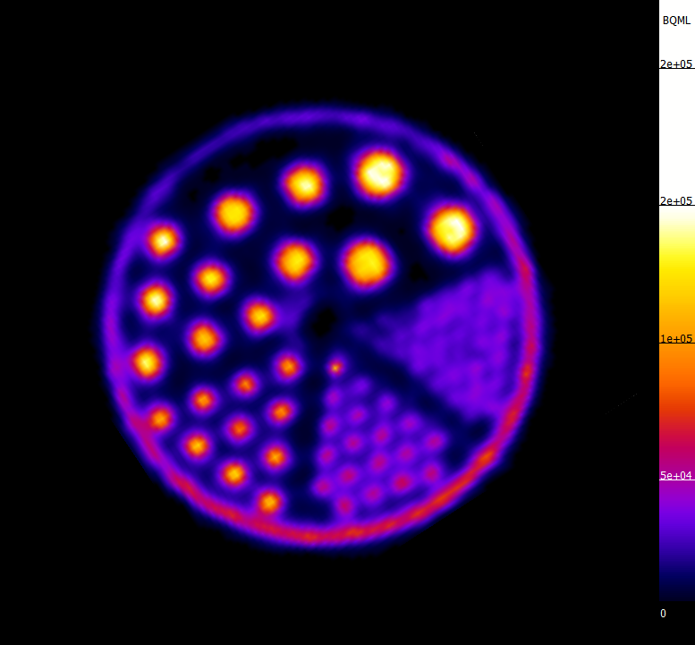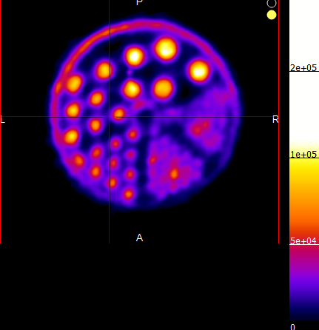

FIGURE 3. PET images acquired using ¹⁸F (top panel) ⁴⁵Ti (bottom panel).

Conclusions and Future Work
These preliminary results are promising, and we are continuing our studies to further investigate the applications of this isotope. We are optimizing the separation method in order to increase recovery yields as well as conduct more in-depth labeling and imaging studies. Work is ongoing to develop a faster separation method that will allow for the collection of the bulk ⁴⁵Ti in a smaller volume. We also aim to move towards pre-clinical imaging studies and determine the in vivo characteristics of ⁴⁵Ti.

References
1. Holland, J.P., Y. Sheh, and J.S. Lewis, Standardized methods for the production of high specific-activity zirconium-89. Nuclear Medicine and Biology, 2009. 36(7): p. 729-739.
2. Price, R. (2015). Titanium-45 as a Candidate for PET Imaging: Production, Processing & Applications (Radiopharmaceutical Production & Development (RAPID) Laboratory,).
3. Queern S.L , Aweda T.A ,Massicano A.V.F, Clanton N.A ,El Sayed R., Sader J.A, Zyuzin A., Lapi S.E, Production of Zr-89 using sputtered yttrium coin targets, Nuclear Medicine and Biology, Volume 50, 2017,Pages 11-16,ISSN 0969-8051,
4. Severin, G. W. (2015). Bringing Radiotracing to Titanium-Based Antineoplastics: Solid (Technical University of Denmark) [Abstract]. Journal of Medicinal Chemistry.
5. Vāvere AL, Laforest R, Welch MJ. Production, processing and small animal PET imaging of titanium-45. Nucl Med Biol. 2005;32(2):117-22

Acknowledgements
We would like to thank the UAB cyclotron engineers and the Lapi Lab members for their support and thoughtful conversations. We would like to thank Samuel Ferran for his help. We would also like to thank UAB Radiology for providing funding for this project and Dan Long at the UAB machine shop.

