Comparison of gas phase and wet methods of [¹¹C]CH₃I preparation for [¹¹C]choline and [11C]methionine synthesis
P. Rajec¹, P.Kruk, M. Leporis, I. Mítová, L. Rada, O.Szöllös, M. Štefečka, D. Tothová

BIONT, Karloveska 63, 842 29 Bratislava, Slovakia

Introduction
[¹¹C]methyl iodide is the most versatile precursor for labeling of ¹¹C radiopharmaceuticals. The oldest methods for [¹¹C]CH₃I so-called “wet” method was developed in seventies by Comar et al. The wet method is very reliable method for producing of [¹¹C]CH₃I and is based on the reaction of ¹¹CO₂ with LiAlH₄ in THF and followed by reaction of [¹¹C]methanol with HI. An alternative method “gas phase” method was developed in nineties by Larsen and proved better s.a. for [¹¹C]CH₃I product. The method is based on conversion of ¹¹CH₄ to [¹¹C]CH₃I by free radical iodination with iodine vapor at the temperature 720 ºC.
In our company we used for routine preparation of [¹¹C]CH₃I gas phase reaction from ¹¹CH₄ prepared by proton irradiation of 10% H₂/N₂ target mix. During years of production [¹¹C]methionine and [¹¹C]choline in our company we have found a necessity of back up production to be able produce [¹¹C] radiopharmaceuticals without pause during repairmen of modules. We started to validate production of [¹¹C]methionine and [¹¹C]choline with wet methods using a standard AllinOne module from Trasis and cassettes from the same company.
For synthesis of [¹¹C]choline and [¹¹C]methionine we used TracerlabFX_{C} for [¹¹C]CH₃I preparation of methylation reagent and GPF-101 for [¹¹C]choline and [¹¹C]methionine synthesis or AllinOne module from Trasis.

Material and Methods
TracerlabFX_{C} GE, GPF-101 Veenstra Instrument, 2-(dimethylamino)-ethanol (DMAE) ABX, Sep-Pak Light Accell Plus CM cation-exchange cartridges Waters used without conditioning, 50 µL of DMAE dissolved into 25 µL of ethanol and loaded on to a CM Sep-Pak, 2 mg precursor (L-HCT ) dissolved in the mixture ethanol/water/1M NaOH and loaded on 18C column Waters, Trasis, methionine and choline cassettes and reagents.
Schematic diagram of the automated system for the production of [¹¹C]choline, [¹¹C]methionine for GPF-101 and Trasis module are given below. [¹¹C]CH₄ was produced in 11C target developed in BIONT by irradiation of mixture N₂/10%H₂ with 17 MeV protons. [¹¹C]CO₂ was produced in standard Nirta 11C target made by IBA by irradiation of mixture N₂/1%O₂ with 15 MeV protons.

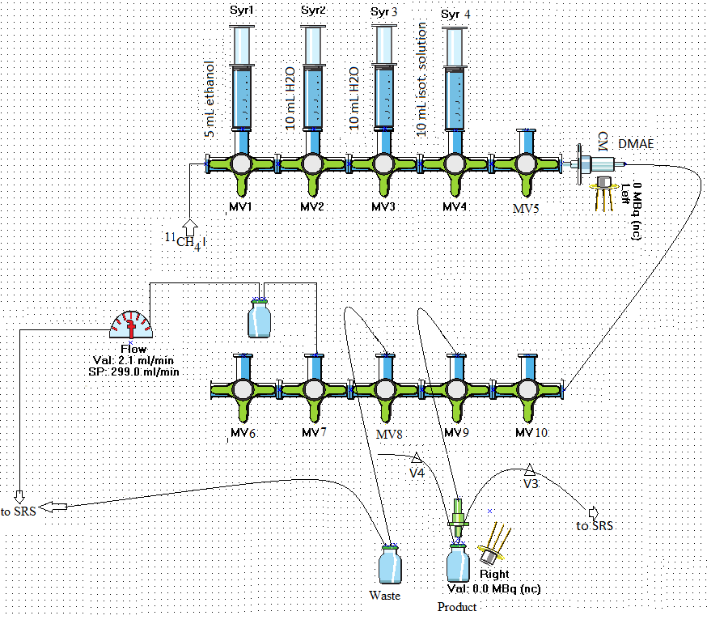

General layout used for the synthesis of [¹¹C]Choline on the GPF-101 synthesizer

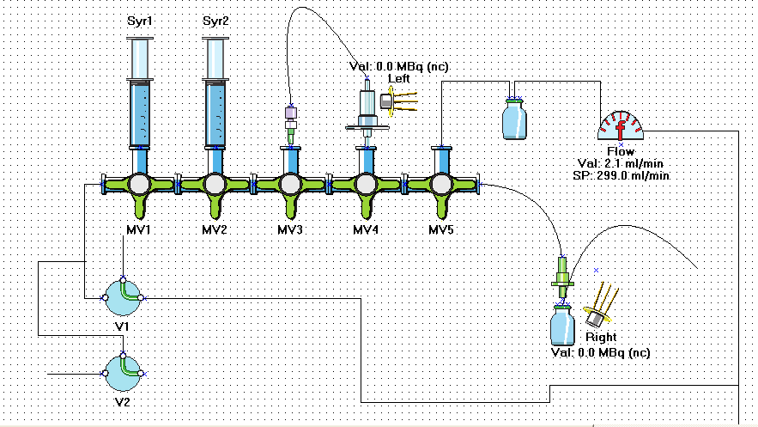
General layout used for the synthesis of [¹¹C]Methionine on the GPF-101 synthesizer

General layout used for the synthesis of [¹¹C]Choline on the AllinOne synthesizer

General layout used for the synthesis of [¹¹C]Methioninene on the AllinOne synthesizer

Results and Conclusion
[¹¹C]CH₄ was prepared in the BIONT targets and connected with TracerlabFX_{C}. [¹¹C]CH₃I was prepared in a loop in which was allowed [¹¹C]CH₄ reaction with the elemental iodine at a temperature 720ºC. Conversion to [¹¹C]CH₃I is usually around 50% uncorrected activity. Activity is in the range 15-18 GBq of [¹¹C]CH₃I and time of production 10 minutes.
Synthesis of [¹¹C]choline is based on the reaction DMAE with [¹¹C]CH₃I on a Accell Plus CM cation-exchange column and [¹¹C]Methionine is based on the reaction L-HCT with [¹¹C]CH₃I on 18C column which serves as a support for reaction.
Production of [¹¹C]Methionine an [¹¹C]choline during 2016 and 2017 is shown in Tab. 1

Table 1. Number of batches of [11C]Methionine and [11C]choline during 2016 and 2017
products | No Batch 2016 | No Batch 2017
[¹¹C]Methionine | 285 | 265
[¹¹C]choline | 24 | 28

Typical non decay corrected yield and time of synthesis of[¹¹C]Methionine and [¹¹C]choline using gas phase method is shown in table.2

Table 2 Non decay corrected yield and time of synthesis of[11C]Methionine and [11C]choline using gas phase method.
products | NDC yield % | Time of synthesis [min]
[¹¹C]Methionine | > 18 | 27
[¹¹C]choline | > 21 | 31

Non decay corrrected yield and time of synthesis of[¹¹C]Methionine and [¹¹C]choline using gas phase method is shown in Tab.3

Table 3 Non decay corrrected yield and time of synthesis of[11C]Methionine and [11C]choline using wet method with Trasis preliminary results.
products | NDC yield % | Time of synthesis [min]
[¹¹C]Methionine | > 30 | 16
[¹¹C]choline | > 29 | 15

Conclusion
We have applied a simple synthesis method for [¹¹C]Choline and [¹¹C]Methionine preparation using automated GPF 101 module and commercial Trasis equipments with precursor fixed on CM or 18C columns. Routinely we are using the gas phase methods for the preparation of [¹¹C]CH₃I. Due to the reason of back up of ¹¹C radiopharmaceuticals production we have started with wet method of [¹¹C]CH₃I preparation and synthesis at Trasis module. From the preliminary results it seems that [¹¹C]Choline and [¹¹C]Methionine fulfill all acceptance criteria in QC control and a yield of non decay corrected for both products was 29 % after 16 minutes.

References
1. D. Comar, M. Maziere,M. Crouzel: Radiopharm. Labeled Compd. pp. 461-469, 1973

2. P. Larsen, J. Ulin, K. Dahlstrom, J. Label Compds. 37, pp. 73–75, 1995.

