Chromium/Manganese Separation via Ion Exchange Column with Application to Octadentate Chelator
Kendall E. Barrett ^{a,1}, Eduardo Aluicio-Sarduyª, Xiaozhu Wang^{b}, Christopher Kutyreffª, Aeli P. Olsonª, Paul A. Ellisonª , Todd E. Barnhartª, Robert J. Nicklesª, Jonathan W. Engleª

ª The University of Wisconsin – Madison, Department of Medical Physics
^{b} The University of British Columbia – Department of Chemistry

Introduction

Manganese, as a radiotracer, has proven its benefits in nuclear medicine. It’s applications to Positron Emission Tomography (PET) and dual-modality manganese-enhanced Magnetic Resonance Imaging (MEMRI) have provided accurate imaging of liver, bone, intestines, and pituitary glands in small animal testing [1]. Along with favorable results in animal studies, manganese as a radiotracer (e.g., ⁵¹Mn and ^{52g}Mn) shows promises in applications such as neural tractography, stem cell tracking, and pancreatic functional imaging in humans[2] This abstract focuses on the production and utilization of ^{52g}Mn, produced from proton irradiation of chromium targets.

To take full advantage of this beneficial element, isolation of ⁵²Mn from the ^{nat}Cr target is required along with chelation of the pure product. Chromium is toxic to the human body, therefore, poor separation risks the health of clinical subjects.

Material and Methods

To produce ^{52g}Mn, a natural chromium target was pressed onto a silver disk and irradiated with a 16 MeV proton beam to achieve an integrated fluence of 80 uAh. Once removed from the cyclotron, the target was placed on a dissolution block under 2 mL of 11.1 M HCl and heated for an hour at 65 °C.

Once dissolved, the target solution was evaporated until dryness with the use of a hot block and constant argon gas flow. After being completely evaporated, the target solute was taken up in 2 mL of 98/2 (v/v) ethanol and 11.1 M HCl.

Three AG-1x8 anion exchange columns were prepared, each with ~300 mg of resin. Columns were equilibrated with, 5 mL of 0.1M HCl, 10 mL of H2O, and 5 mL of 98/2 EtOH/HCl.

Upon reconstitution of target material in 98/2 EtOH/HCl and preparation of columns, the target solution was loaded onto the first column, trapping ^{52g}Mn. After the load, 30 mL of 98/2 EtOH was used to wash the column, removing bulk chromium from the ^{52g}Mn. These 30 mLs were collected for analysis. ^{52g}Mn was eluted in 0.1M HCl and evaporated again to dryness. This solid was taken back up in 200 uL of 11.1 M HCl and 9.8 mL of EtOH to achieve a 98/2 EtOH solution. The process for loading, washing, and eluting the column was repeated for columns two and three, with an additional dry down and dissolution of the target solution between the second and third column.

The final elution from the third column was taken in 1 mL fractions so that the concentration of chromium in fraction 1, 2, 3, and 4 could be analyzed by MP-AES.

Due to the natural enrichment of the target, ^{52g}Mn, ⁵⁴Mn and ⁵¹Cr were created through the irradiation. Therefore, the solution contained natural chromium, radioactive chromium, and two isotopes of manganese with varying half-lives.

After the separation was complete, the samples were tested with different concentrations of ligands for determination of apparent molar activity. The chosen ligands were DOTA and H4Octox. DOTA is commonly used for chelation of various metals, whereas H4Octox is a new octadentate ligand specific to Mn chelation developed at the University of British Columbia. The same procedure was followed for each ligand: 100 uL of ligand solution added to an empty vial with 50 uL of .5M NaOAc buffer of pH 5.5, then 100 uL of ^{52g}Mn in 0.1 M HCl was added. The vials were vortexed, assayed, and spotted at different time points on aluminum backed silica TLC plates. The TLC mobile phase was .1M Sodium Citrate.

Results and Conclusion

Microwave plasma atomic emission spectroscopy (MP-AES, Agilent) results for trace metals in diluted wash and elution solutions are shown in Table 1.
Column 1 | Fraction | Volume | Cr concentration (ppm)
 | Elution 1 | 1 mL | 2.50E+06
 | Elution 2 | 1 mL | 1.64E+05
 | Elution 3 | 1 mL | 6.89E+04
 | Elution 4 | 1 mL | 5.23E+04
Column 2 | Elution 1 | 1 mL | 2.28E+03
 | Elution 2 | 1 mL | 4.65E+03
 | Elution 3 | 1 mL | 5.65E+03
 | Elution 4 | 1 mL | 3.76E+03
Column 3 | Elution 1 | 1 mL | 5.32E+01
 | Elution 2 | 1 mL | 1.56E+02
 | Elution 3 | 1 mL | 9.36E+01
 | Elution 4 | 1 mL | 3.88E+01
Table 1. MP-AES Results for Concentration of Chromium in Elution Samples

These results gave insight that the resulting fractions from the third column elution could be used for chelation experiments due to a separation factor of approximately 1.0e4. The data collected from spotting the DOTA and H4Octox on TLC plates at various time points at room temperature are shown in the figures and tables below. The percent of chelated manganese is shown in region 1 and the percent of free manganese is region 2.

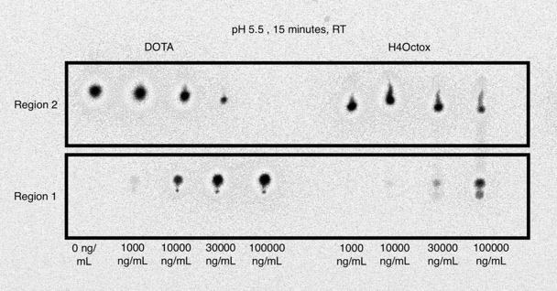
Figure 1: TLC plate of DOTA and H4Octox chelation after 15 minutes at room temperature.

Moles of Chelator (ng/mL) | Region 1 (% bound) | Region 2 (% free)
0 | 1.9 | 98.1
1000 | 3.5 | 96.5
10000 | 28.6 | 71.4
30000 | 80.4 | 19.6
100000 | 97.5 | 2.5
Table 2. DOTA chelation at 15 minutes at room temperature

Moles of Chelator (ng/mL) | Region 1 (% bound) | Region 2 (% free)
1000 | 2.7 | 97.3
10000 | 3 | 97
30000 | 16.3 | 83.7
100000 | 59.8 | 40.2
Table 3. H4Octox chelation at 15 minutes at room temperature

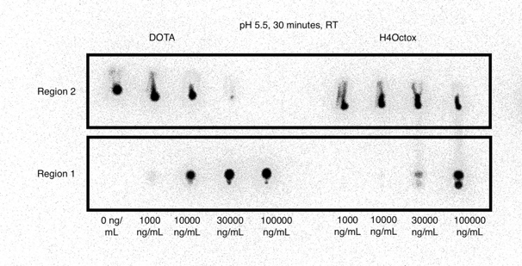
Figure 2: TLC plate of DOTA and H4Octox chelation after 30 minutes at room temperature

Moles of Chelator (ng/mL) | Region 1 (% bound) | Region 2 (% free)
0 | 1.3 | 98.7
1000 | 4 | 96
10000 | 40.5 | 59.5
30000 | 94.1 | 5.9
100000 | 97.6 | 2.4
Table 4. DOTA chelation at 30 minutes at room temperature

Moles of Chelator (ng/mL) | Region 1 (% bound) | Region 2 (% free)
1000 | 1.6 | 98.4
10000 | 2 | 98
30000 | 14.8 | 85.2
100000 | 59.9 | 40.1
Table 5. H4Octox chelation at 30 minutes at room temperature
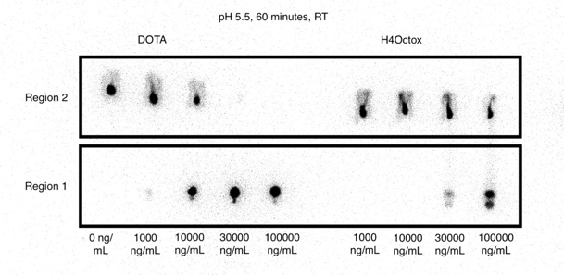Figure 3: TLC plate of DOTA and H4Octox chelation after 60 minutes at room temperature
Concentration (ng/mL) | Region 1 (% bound) | Region 2 (% free)
0 | 0.06 | 99.94
1000 | 33 | 67
10000 | 55.5 | 44.5
30000 | 97.8 | 2.2
100000 | 98.8 | 1.2
Table 6. DOTA chelation at 60 minutes at room temperature

Concentration (ng/mL) | Region 1 (% bound) | Region 2 (% free)
1000 | 1.4 | 98.6
10000 | 1.7 | 98.3
30000 | 16.1 | 83.9
100000 | 58.7 | 41.3
Table 7. H4Octox chelation at 60 minutes at room temperature

The apparent molar activities for the DOTA ligand at 15, 30, and 60 minutes were 259.0 MBq/umol, 333.0 MBq/umol, and 444.0 MBq/umol respectively. The apparent molar activities for Mn chelation with H4Octox remained constant over the time points, maintaining a value of 74.0 MBq/umol.
These results suggest that H4Octox can be utilized for chelation of Mn. With a better separation of Mn from bulk Cr and varying the pH for the complexation reaction, H4Octox has the potential to be a preferable ligand for binding ^{52g}Mn due to its specificity for the metal and ability to react at room temperature.

References
1. GJ Topping et al., “Manganese-52 Positron Emission Tomagraphy Tracer Characterization and Initial Results in Phantoms and In Vivo.” Med Phys 40: 042502 (2013).
2. SA Graves et al., “Novel Preparation Methods of Mn-52 for ImmunoPET Imaging” Bioconjug Chem 26: 2118-2124 (2015).

