Using an Aqueous Target and a Fast Heavy Ion Beam for Radionuclide Production at a Heavy-Ion Fragmentation Facility
E.P. Abel^{a,1} , H.K. Clauseª, G.W. Severinª
ª Michigan State University, East Lansing, MI 48915, U.S.A.

Introduction
Targeted internal radiotherapy is a promising new treatment method for metastatic cancer. Several scandium isotopes, ^{43,44,47}Sc, could serve as paired diagnostic and therapeutic isotopes for these diseases ^{1,2}. However, an ideal production method for the therapeutic isotope ⁴⁷Sc currently has not been found ³⁻⁹. At the National Superconducting Cyclotron Laboratory, we have the opportunity to harvest ⁴⁷Ca when the ⁴⁸Ca primary beam is run to produce a user-specified secondary radioactive beam. Much of this primary beam goes unreacted and is collected in beam stops. The ⁴⁸Ca primary beam produces ⁴⁷Ca as one of the most abundant fragments when the beam is stopped in a water target. The collection of ⁴⁷Ca will allow for a clean separation from the aqueous mix of ions produced and the production of ⁴⁷Sc using a ⁴⁷Ca/⁴⁷Sc generator.
Current radiochemistry efforts at the NSCL involve making a beam blocker system in which radionuclides such as ⁴⁷Ca are produced from the implanted primary beam in the beam stop cooling water. A preliminary experiment was run at the NSCL using the most recent beam blocker system design. This experiment demonstrated the production of radionuclides in the aqueous target and the collection of these ionic species on ion exchange resins. In addition, this experiment provided information on the rate of corrosion of the target window material from a radiotracer analysis.
Material and Methods
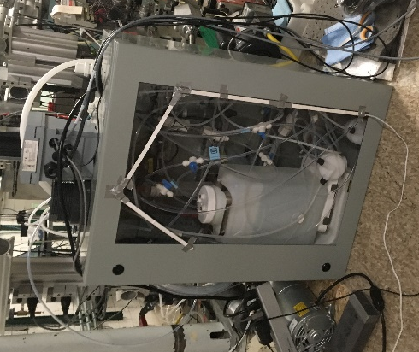
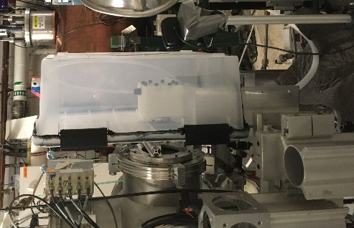
A ⁴⁰Ca²⁰⁺ beam was used for a preliminary experiment to test the current aqueous beam blocker system. This beam was used at two different intensities: 0.12 pnA for about 17 minutes and 0.45 pnA for approximately 3.5 hours. The initial lower intensity beam was used to monitor the system conditions for a short time before increasing the intensity to observe any degradation of the target window and produce radionuclides at a higher rate in the system. The target window material was chosen to be the Ti6Al4V alloy due to its well-known resistance to corrosion. The aqueous beam blocker system includes a pump that continuously circulates water from a reservoir through polypropylene tubes, which connect all components of the system. Sensors, such as a conductivity probe, a pH probe, and a dissolved O₂ sensor, can monitor the conditions of the water. Additionally, membrane contactors are used to allow for a separation of gas from the water and ion exchange resins (AG 50W-X8 and AG 1X8) are used to extract ions produced in the water. Pictures and a schematic of the experimental set up are shown in Figure 1 and 2, respectively.
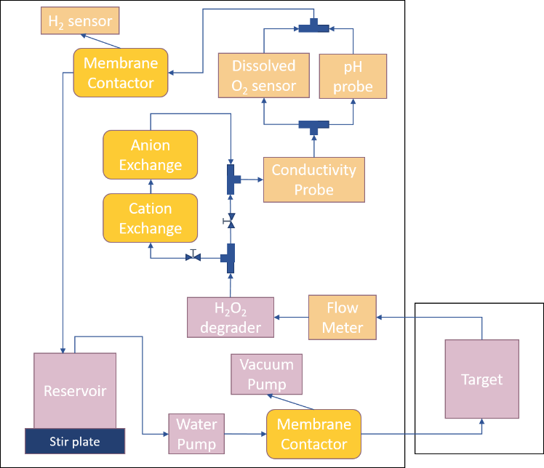
For this experiment approximately 6 L of ultra-pure water was used. The water was also run through both a cation and anion exchange resin prior to irradiation to reduce the conductivity of the water to about 250 nS/cm. The irradiation was performed for about 4 hours and the resulting conductivity was allowed to build up in the system to be monitored by the conductivity probe. Following the irradiation, the water was pumped through ion exchange resins until the conductivity had reached a minimum of about 100 nS/cm. Components of the system including the ion exchange resins were analyzed using gamma spectroscopy to identify and quantify the radionuclides produced by irradiating the aqueous target.
Figure 1. Aqueous Beam Blocker System: aqueous target at the end of the beam line (left) and the system of harvesting and monitoring components sitting behind the beam line.
Results and Conclusion
Throughout the irradiation, the conductivity in the system increased in a very linear manner from a baseline of about 800 nS/cm to a final value of 1.8 μS/cm. This level of conductivity persisted even after the irradiation. The dissolved ions were collected on ion exchange resins after irradiation. The only activity detected in the reservoir water after collecting the ions was a small fraction of the ¹⁸F activity, showing that the ion exchange resins provide a sufficient separation technique for harvesting ions from an aqueous system. The contents of the columns were eluted and will be analyzed with Inductively Coupled Plasma-Optical Emission Spectroscopy to determine the identity and amount of the dissolved ions in the system.
Figure 2. Schematic of the Current Aqueous Harvesting System. The system is composed of mechanical components (purple), sensors and probes (orange), and separation tools (yellow). The flow of water through the system is shown by the arrows.
The radionuclides collected on the resins were identified and quantified by their characteristic gamma emissions. These production activities were compared to predicted levels using LISE++ to estimate fragmentation reaction rates and both Lisfus and PACE4 to estimate fusion-evaporation reaction cross sections in the aqueous target ¹⁰⁻¹². Both the total activity detected in the system as well as the estimated productions for fragmentation and fusion-evaporation products are shown in Table 1 and 2, respectively. The measured and estimated activities are reasonably close for most of the nuclides detected with a few notable exceptions: ⁷Be, ²⁸Mg, and ⁵²Mn.
Nuclide | Total Measured Production, μCi | LISE++ Estimated Production, μCi
⁷Be | 0.47(8) | 0.041
¹⁸F | 84.4(3) | 46.2
²⁴Na | 3.4(3) | 7.15
²⁸Mg | 0.047(4) | 0.42
^{34m}Cl | 121(24) | 46.2
Nuclide | Total Measured Production, μCi | PACE4 Estimated Production, μCi | Lisfus Estimated Production, μCi
⁴³Sc | 1.16(8) | 1.76 | 4.11
^{44m}Sc | 0.10(1) | 0.14 | 0.79
⁴⁸V | 0.016(6) | 0.038 | 0.011
⁴⁸Cr | 0.021(5) | 0.15 | 0.56
⁵²Mn | 0.018(1) | 0.057 | 0.11
Degradation of the Ti6Al4V window material was limited by using ⁴⁷Sc as a radiotracer. This scandium isotope is produced in the target window with an activity of 0.5(1) μCi at EOB. However, no activity from ⁴⁷Sc was detected in the water or on the ion exchange resins. By finding a limit of detection of the characteristic 159.3 keV γ-ray for ⁴⁷Sc, it was found that ≤ 0.26(2)% of the ⁴⁷Sc produced in the window could have been deposited in the water as degradation of the window occurred throughout the irradiation ¹³. This can be roughly equated to ≤ 5 μg of the 1 g titanium window degrading during the irradiation.
TABLE 1. Measured and Estimated Activities of Fragmentation Products at EOB.
TABLE 2. Measured and Estimated Activities of Fusion-Evaporation Products at EOB.

References
1. C. Müller, M. Bunka, S. Haller, U. Köster, V. Groehn, P. Bernhardt, N. van der Meulen, A. Türler, R. Schibli, Journal of Nuclear Medicine 55, 1658 (2014).
2. C. Müller, M. Bunka, J. Reber, C. Fisher, K. Zhernosekov, A. Türler, R. Schibli, Journal of Nuclear Medicine 54, 2168 (2013).
3. R. Misiak et. al, Journal of Radioanalytical Nuclear Chemistry 313, 429 (2017).
4. M.U. Khandaker et. al., Applied Radiation and Isotopes 67, 1348 (2009).
5. L.F. Mausner, K.L. Kolsky, V. Joshi, S.C. Srivastava, Applied Radiation and Isotopes 49, 285 (1998).
6. K.A. Domnanich, C. Müller, M. Benešová, R. Dressler, S. Haller, U. Köster, B. Ponsard, R. Schibli, A. Türler, N.P. van der Meulen, European Journal of Nuclear Medicine and Molecular Imaging 2, 5 (2017).
7. S. Rane, J.T. Harris, V.N. Starovoitova, Applied Radiation and Isotopes 97, 188 (2015).
8. M. Yagi, K. Kondo, International Journal of Applied Radiation and Isotopes 28, 463 (1977).
9. M. Mamtimin, F. Harmon, V.N. Starovoitova, Applied Radiation and Isotopes 102, 1 (2015).
10. O.B. Tarasov, D. Bazin, Nuclear Instruments and Methods in Physics Research B 266, 4657 (2008).
11. A. Gavron, Physics Review C 21, 230 (1980).
12. O.B. Tarasov, D. Bazin. Nuclear Instruments and Methods in Physics Research B 204, 174 (2003).
13. T. W. Burrows, Nuclear Data Sheets 108, 923 (2007).

Acknowledgements
We would like to thank Mathias Steiner, Frederique Pellemoine, Nicolas Dronchi, Jason Hart, and Marina Llewellyn for their help with this work. This research was supported by the DOE NNSA SSGF Program; Michigan State University; and the National Superconducting Cyclotron Laboratory NSF-1565546.

