Solid Target Developments at the Bern medical Cyclotron
Tommaso Stefano Carzanigaª, Philipp Häffnerª, Andreas Türler^{b}, Saverio Braccini^{a,1}

ªAlbert Einstein Center for Fundamental Physics (AEC), Laboratory for High Energy Physics (LHEP), University of Bern, Sidlerstrasse 5, CH-3012 Bern, Switzerland
^{b}Department of Chemistry and Biochemistry (DCB), University of Bern, Freiestrasse 3, CH-3012 Bern, Switzerland

Introduction
The production of novel medical radioisotopes for theranostics will be essential for the development of personalized nuclear medicine. Among them, radiometals can be used to label proteins and peptides and their optimized supply in quantity and quality for clinical applications represents a scientific and technical challenge. Along this line, medical cyclotrons [1] and irradiation methods have to be further developed.
A research program aimed at the production of PET radio-metals (Ga-68, Cu-64, Sc-44, and Sc-43) is ongoing at the Bern medical cyclotron [2], where a solid target station with a pneumatic delivery system was recently put in operation. To bombard isotope-enriched materials in form of compressed powders, a specific target coin was conceived and tested. To assess the produced activity at EoB a system based on a CZT detector was developed. The first promising results are presented here and constitute the basis for further developments. In particular, we aim at enhancing the production capabilities of compact solid target stations. For this purpose, the development of a novel irradiation system based on an ultra-compact ~50 cm long beam line and a two-dimensional beam monitoring detector is on-going.

Material and Methods
The Bern medical cyclotron [2] laboratory is based on an IBA Cyclone 18/18, which is daily used for routine production of F-18 and for multi-disciplinary research activities. It is equipped with a Beam Transport Line (BTL) bringing the proton beam to a second bunker, which can be accessed for scientific experiments without radiological hazards.
A IBA Nirta Solid target station was installed on one of the out-ports of the cyclotron to pursue our research program on novel medical radioisotopes, Sc-43 in particular. This device was initially equipped with a manual target recovery system, which presented severe radiation protection limitations, especially in view of the high (several GBq) envisaged activities. For this reason, a pneumatic transfer system by the company TEMA Sinergie was installed to automatically deliver the irradiated target to the hot-cells, as shown in Fig. 1.
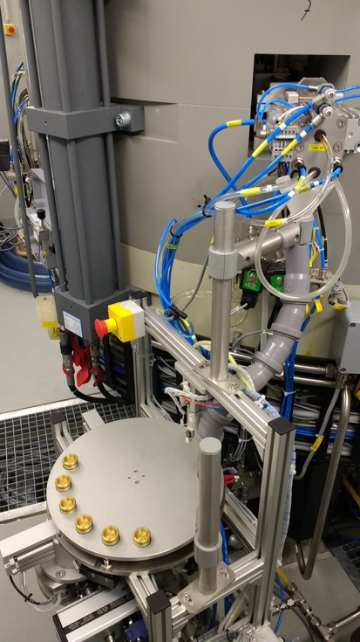
Fig 1. The solid target station of the Bern medical cyclotron with the pneumatic transfer system equipped with six shuttles and two delivery paths.
Since the target is often transferred to external research laboratories for separation and labeling, this system was customized including the possibility to deliver the target also in the research bunker. In this way, the irradiated target can be efficiently collected to be shipped without involving the radio-pharmacy.
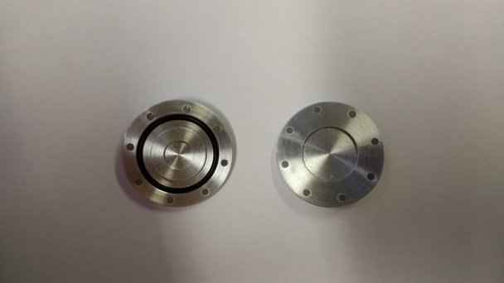
Fig 2. The two halves of the “coin” target. The rear half (on the left) contains the 6 mm dimeter pellet and hosts an o-ring to assure gas tightness. The front part (on the right) is used to degrade the beam to the desired energy.
The IBA Nirta Solid target station was designed to bombard material electroplated on 24 mm diameter 2 mm thick disks usually made of gold or platinum. Among the isotopes we aim at producing, this is the case of Cu-64 produced from enriched Ni-64 but not of Ga-68 and Sc isotopes. Ga-68 and Sc-43/Sc-44 can be produced by irradiating powders of Zn and CaCO3 or CaO (as presented in another abstract submitted to this conference), respectively. The irradiation of enriched materials in form of powders is challenging and, for this purpose, a specific “coin” was conceived and constructed. As shown in Fig. 2, the coin has the same external dimensions as the disk but is composed of two halves kept together by small permanent magnets. The choice of its components and its manufacturing is challenging. In particular, the magnets should not lose their properties due to the high temperatures reached during irradiation. It has to be noted that the coin is cooled by water on the back and by helium on the front side. The coin is constructed in an aluminum alloy (EN AW-6082) and other materials are under study. The front window of the coin is used to adjust the energy of the protons reaching the target material which consists of a pellet of compressed powder or of an electroplated sample. Since the cost of enriched material is very often high, 30 mg of CaO were used for the case of Sc-44, leading to a pellet of 500 um thickness and of 6 mm diameter. Being the beam ~12 mm FWHM in standard irradiation conditions, only about 25% of the extracted protons are effectively used to produce the desired isotope. This is an issue which has to be improved. Some powder materials are available in form of oxide and the reaction O-16(p, alpha) N-13 produce relevant amount of activity in gas form that provokes radiation protection issues. For this reason, an o-ring was embedded in the coin to contain the radioactive gas.
To assess the produced activity after EoB and the delivery of the shuttle, a CZT detector system was designed and installed in the BTL bunker, about 2 m away from the receiving station. Based on a ~1 cm³ CdZnTe crystal (GBS Elektronik), the detector allows recoding the energy spectra of the emitted photons. The low detection efficiency due to the distance and the small volume of the crystal is well suitable for the high produced activities.

Results and Conclusion
The production of Cu-64 was first tested using 63 mg of Ni-64 electroplated on a 10 mm diameter gold disk. The impinging energy was set to 12 MeV, considering the 18 MeV pristine beam energy and the losses on the exit window of the target station and on the front of the coin. With an irradiation of 10 hours with ~15 μA on target, ~30 GBq of Cu-64 were produced in agreement with the calculations based on the cross-sections. Sc-44 production tests followed (as also reported in another abstract submitted to this conference). A pellet of 30 mg of CaO (enriched in Ca-44 at 99%) was irradiated for 6 hours with 18 μA on target (corresponding to ~4.5 μA on pellet) at 12 MeV and an activity of ~16 GBq was produced at EoB. This represents an unprecedented achievement with a medical cyclotron. The result is found to be in agreement with our published results on the cross sections [3].
The same procedure was used to produce thin V-48 foil sources for positron beams [4]. A 1 μm thick natural titanium foil of 650 μg was irradiated for 30 minutes with 20 μA. An activity of 400 kBq was obtained, more than a factor 10 with respect to standard methods based on the irradiation of foils placed along the path of a proton beam.

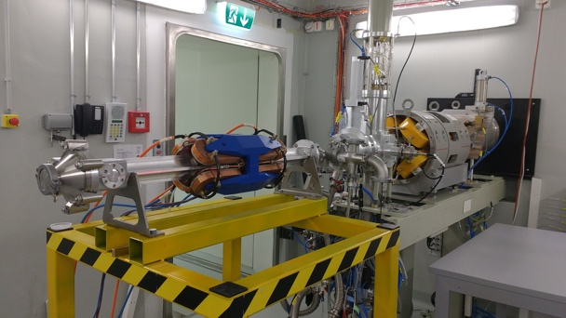
Fig 3. The MiniBeamLine under test in the BTL bunker of the Bern medical cyclotron laboratory.
On the basis of this encouraging preliminary results, further developments and investigations are on-going aimed at enhancing the production capabilities of radioisotopes using medical cyclotrons and solid targets. The heat conduction in the target is a crucial issue and a model based on the COMSOL software has been developed to improve the design of the coin. The beam characteristics are studied for the BTL and the out-port where the solid target is installed [5]. An optimal irradiation of small pellets can be obtained by focusing the beam on the ~6 mm diameter pellet and to keep it always on target. This will be realized with a novel irradiation system composed by a compact ~50 cm long beam line and a two-dimensional beam monitoring detector and a feedback system. The detector is based on silica scintillating fibers moved through the beam and was designed and realized by our group [6]. This device – named UniBEaM – is now commercialized by the Canadian company D-Pace [7]. The compact MiniBeamLine by D-Pace is shown in Fig. 3. Its characterization is underway using the BTL.
These results represent a valuable step towards the establishment of efficient and reliable non-standard radioisotope production methods in view of personalized medicine.

References
1. S. Braccini: Proceedings of Cyclotrons2016, TUD01, Zurich, Switzerland, 2016, pp. 229–234, http://www.jacow.org.
2. S. Braccini: AIP Conference Proceedings 1525 (2013) 144–150.
3. T. S. Carzaniga, M. Auger, S. Braccini, M. Bunka, A. Ereditato, K. P. Nesteruk, P. Scampoli, A. Türler, N. van der Meulen, : Appl. Radiat. Isot. 127, pp. 96–102, 2017.
4. L. Gerchow, D. Cooke, S. Braccini, M. Döbeli, K. Kirch, U. Köster, A. Müller, N. P. Van Der Meulen, C. Vermeulen, A. Rubbia, and P. Crivelli: arXiv:1703.06198, March 2017.
5. K. P. Nesteruk, M. Auger, S. Braccini, T. S. Carzaniga, A. Ereditato, P. Scampoli: JINST 13, P01011, 2018
6. M. Auger, S. Braccini, T. S. Carzaniga, A. Ereditato, K. P. Nesteruk, P. Scampoli: JINST 11 (03) P03027, 2016
7. www.d-pace.com

Acknowledgements
We acknowledge contributions from LHEP engineering and technical staff. This research project was financially supported by the Swiss National Science Foundation (grant CR23I2 156852).

