Cross-section measurements at the Bern Medical Cyclotron
Tommaso Stefano Carzaniga^{a,1}, Nicholas van der Meulen^{b,c}, Andreas Türler^{d},
Diana Würtrichª, Saverio Bracciniª

ªAlbert Einstein Center for Fundamental Physics (AEC), Laboratory for High Energy Physics (LHEP), University of Bern, Sidlerstrasse 5, CH-3012 Bern, Switzerland
^{b}Laboratory of Radiochemistry, Paul Scherrer Institut, CH-5232 Villigen, Switzerland
^{c}Center of Radiopharmaceutical Sciences, Paul Scherrer Institut, CH-5232, Villigen, Switzerland
^{d}Department of Chemistry and Biochemistry (DCB), University of Bern, Freiestrasse 3, CH-3012 Bern, Switzerland

Introduction
The production of novel medical radioisotopes through the bombardment of isotope-enriched materials using solid targets and compact cyclotrons represents a scientific and technological challenge [1]. In order to optimize the production yield and the radio-nuclide purity, precise knowledge of the cross-section as a function of the beam energy is crucial and existing nuclear data are often insufficient or contradictory.
A research program aimed at the production of PET radio-metals as Ga-68, Cu-64, Sc-44, and Sc-43 is ongoing at the Bern Medical Cyclotron [2] where a solid target station was recently put in operation. A specific method for the assessment of cross-sections with a medical cyclotron was developed [3]. Being based on irradiation by means of a monitored flat beam current surface density, the procedure does not depend on irregularities of thickness of the target material once the full mass is irradiated. This method is well suited for materials in form of powders.

Material and Methods
The cyclotron laboratory at the Bern University Hospital (Inselspital) features an IBA Cyclone 18/18 high current cyclotron and two bunkers with independent access. This solution allows performing both medical radioisotope production and multi-disciplinary research activities [2].
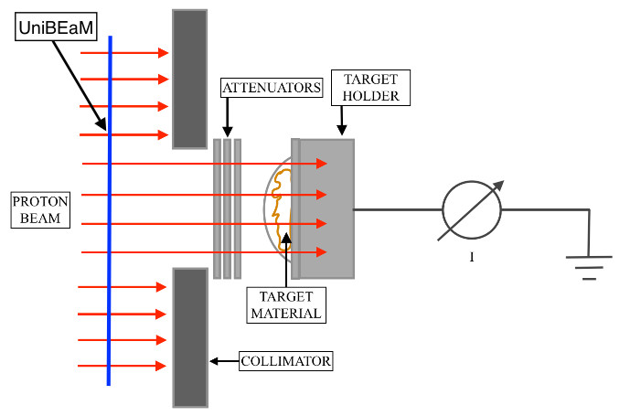
Fig 1. Scheme of the setup of the apparatus used for cross-section measurements.
The beam is brought to the second bunker by means of a 6 m long external Beam Transport Line (BTL) used for the cross-section measurements presented in this abstract.
A specific method to measure cross-sections was developed by our group. It relies on the irradiation of a known mass with a flat beam current surface density instead of the usual homogeneously thick target [3]. As shown in Fig.1, the incoming beam is flattened by means of the optical elements of the BTL and collimated into an area larger than the one occupied by the target material. Protons cross thin aluminum discs used to degrade their energy on target, which was calculated by means of the SRIM Monte Carlo code. The integrated charge due to the protons passing through the collimator is measured together with all the involved physical quantities. All the critical parameters, as the beam current and its flatness, were monitored on-line throughout the full procedure.
This approach requires an advanced knowledge and control of the beam. First, the energy of the beam extracted to the BTL was measured and resulted in a mean energy of (18.3 ± 0.3) MeV with an RMS of 0.40 MeV [4]. The currents required for cross-section measurements are of a few nA, much lower than the ones routinely used for isotope production. For this purpose, a specific method to obtain beams down to the pA range was developed by our group [5].
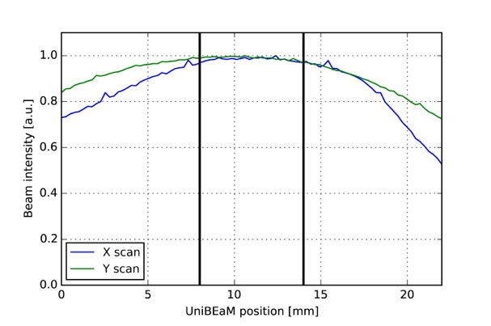
Fig 2. Typical beam profiles during target irradiation. The vertical lines indicate the collimator.

During all irradiations the beam was shaped by quadrupoles and steering magnets to obtain a flatness better than 5% within the surface of the collimator, as shown in Fig. 2.
To measure on-line the position and the shape of the beam – i.e. to guarantee the flatness of the proton surface density - a UniBEaM-2D detector was used. This detector is based on scintillating fibers passed through the beam. It was designed and constructed by our group [6] and is now commercialized by the Canadian company D-Pace [7].

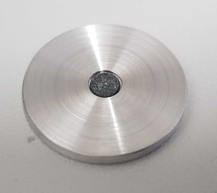
Fig 3. Target substrate with a ~1mg enriched zinc deposition.

The substrate for the target material was a 2 mm thick aluminum disc with a 0.6 mm deep pocket of 4.2 mm in diameter (Fig. 3). The target material was deposited in this pocket by sedimentation from a suspension of a few milligrams of the selected powder in ultra-pure water. The water was evaporated at ∼ 60 − 70 ◦C. The mass of the deposited material was assessed with an accuracy of 2 μg. After cooling, the targets were covered with a 10 μm thin aluminum foil. Since the thickness of the target was estimated to be of the order of few tens of μm, the beam energy could be considered constant within the uncertainties in the full irradiated mass.
During the irradiation, the collimator provided a beam of controlled diameter while an electron suppressor ring, connected to a negative bias voltage of ~50 V volts, was used to repel secondary electrons produced by the interaction of the beam with the target or with the attenuators. The integral charge - i.e. the number of protons on target - was measured by a computer-controlled ammeter (B2985A Keysight). Typical irradiations had currents of the order of tens of nA and each irradiation lasted from few minutes up to half an hour.
After the irradiation, an HPGe detector was used to determine the activity of the produced isotope and of the impurities.
In order to verify the overall method, ^{at}Ti(p,x)⁴⁸V and ^{nat}Cu(p,x)⁶³Zn reference reactions were used according to IAEA recommendations. Those cross-sections were found to be in agreement with respect to the reference values within 5 % [3].

Results and Conclusion
The cross-sections of several nuclear reactions were measured and compared with experimental results from literature and theoretical model predictions.
Cross-section involved in the production of Sc-43 and Sc-44 were measured with the aforementioned method and the obtained results published [3]. From these measurements, thick target yields were calculated.
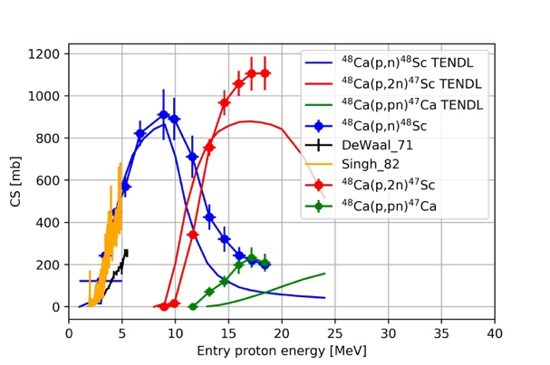
Other reactions are under study and the first preliminary results are reported here.
PRELIMINARY
Fig 4. Production cross-section of Sc-47 from Ca-48 and of Sc-48/Ca-47 impurities.

The production of Sc-47 is studied, as shown in Fig. 4. The results indicate that for optimal production an entry energy of 18 MeV or higher is needed to obtain a large yield and low impurities.
The production of Ga-68 from enriched Zn-68 with solid target is also investigated. This is a very actual theme due to the present high demand of this radioisotope for PET imaging. The results are shown in Fig. 5 and indicate that an entry energy in the target material of 12 MeV is required to have a high yield and an optimal purity. Larger energies have to be avoided.
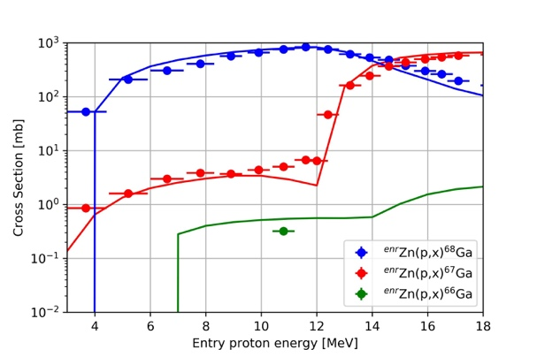
Fig 5. Measured cross-sections aimed at high-purity Ga-68 production from highly enriched Zn-68 metallic powder. The continuous line is TENDL-2015.
PRELIMINARY

The computation of thick target yields from the cross-section data allows an analysis of yields and purity. The preliminary results are shown in Fig. 6 and will be instrumental to define the parameters for the design of the target.
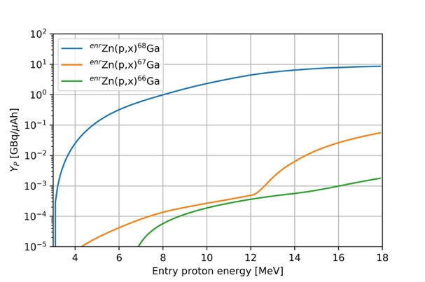
Fig 6. Computed Thick Target Yields of Ga-68 and impurities from highly enriched Zn-68 metallic powder.
PRELIMINARY

These studies represent an essential step for the production of PET radio-metals by irradiation of isotope-enriched materials using medical cyclotrons equipped with a solid target station. Further investigations are on-going aimed at developing knowledge, tools and techniques to bring novel medical radioisotopes to clinical applications.

References
1. S. Braccini: Proceedings of Cyclotrons2016, TUD01, Zurich, Switzerland, 2016, pp. 229–234, http://www.jacow.org.
2. S. Braccini: AIP Conference Proceedings 1525 (2013) 144–150.
3. T. S. Carzaniga, M. Auger, S. Braccini, M. Bunka, A. Ereditato, K. P. Nesteruk, P. Scampoli, A. Türler, N. van der Meulen, : Appl. Radiat. Isot. 127, pp. 96–102, 2017.
4. K. P. Nesteruk, M. Auger, S. Braccini, T. S. Carzaniga, A. Ereditato, P. Scampoli: JINST 13, P01011, 2018
5. M. Auger, S. Braccini, A. Ereditato, K. P. Nesteruk, P. Scampoli: Meas. Sci. Technol. 26 P094006, 2015
6. M. Auger, S. Braccini, T. S. Carzaniga, A. Ereditato, K. P. Nesteruk, P. Scampoli: JINST 11 (03) P03027, 2016
7. www.d-pace.com

Acknowledgements
We acknowledge contributions from LHEP engineering and technical staff. This research project was financially supported by the Swiss National Science Foundation (grant CR23I2 156852).

