Electrodeposition and recovery of Sn targets for ¹¹⁹Sb production

Aeli P. Olsonª, Paul A. Ellisonª, Valery Radchenko^{b}, Todd E. Barnhart, Jonathan W. Engle¹

ªDepartment of Medical Physics, University of Wisconsin, Madison, B1137 WIMR, 1111 Highland Avenue, Madison, WI 53705, USA
^{b}Life Sciences Division, TRIUMF, 4004 Wesbrook Mall, Vancouver BC, V6T 243, Canada

Introduction
Antimony-119 (38.19 h, 100% ε decay) holds promise in targeted radionuclide therapy because of its unique Auger electron energy spectrum and potential for production on small medical cyclotrons [1]. Production, however, is hindered by the relatively low natural isotopic abundance of ¹¹⁹Sn. To apply ¹¹⁹Sb in preclinical experiments, GBq quantity and high radioisotopic purity needs are anticipated. The use of natural isotopic abundance tin targets produces significant radioisotopic impurities (see Table 1). Sustainable productions will require reclamation of enriched Sn target material.

 | T_{1/2} | Production reaction | Target Sn Isotope Natural Abundance
¹¹⁵Sb | 32.1 min | ¹¹⁵Sn(p,n)  ¹¹⁶Sn(p,2n) | 0.34 %  14.5 %
¹¹⁶Sb | 16 min | ¹¹⁶Sn(p,n)  ¹¹⁷Sn(p,2n) | 14.5 %  7.7 %
^{116m}Sb | 60 min | ¹¹⁶Sn(p,n)  ¹¹⁷Sn(p,2n) | 14.5 %  7.7 %
¹¹⁷Sb | 2.8 h | ¹¹⁷Sn(p,n) | 7.7 %
 |  | ¹¹⁸Sn(p,2n) | 24.2 %
^{118m}Sb | 3.5 min | ¹¹⁸Sn(p,n)  ¹¹⁹Sn(p,2n) | 24.2 %  8.6 %
¹¹⁸Sb | 5 h | ¹¹⁸Sn(p,n) | 24.2 %
¹¹⁹Sb | 38.5 h | ¹¹⁹Sn(p,n)  ¹²⁰Sn(p,2n) | 8.6 %  32.6 %
^{120m}Sb | 5.76 d | ¹²⁰Sn(p,n) | 32.6 %
¹²⁰Sb | 15.9 min | ¹²⁰Sn(p,n) | 32.6 %
^{122m}Sb | 4.19 min | ¹²²Sn(p,n) | 4.6 %
¹²²Sb | 2.72 d | ¹²²Sn(p,n) | 4.6 %
^{124m2}Sb | 20.2 min | ¹²⁴Sn(p,n) | 5.8 %
^{124m1}Sb | 93 sec | ¹²⁴Sn(p,n) | 5.8 %
¹²⁴Sb | 60.2 d | ¹²⁴Sn(p,n) | 5.8 %
Table 1. Radioantimony impurities potentially produced from proton irradiation of ^{nat}Sn [2].

Electrochemical deposition provides a reclamation option as it is commonly implemented with other enriched metals, such as the creation of ⁶⁴Cu [3]. Historically, tin deposition is performed with industrial applications including corrosion protection and safe food contact within cookware and food storage containers, however, these plating baths include significant organic additives to control deposition rate, surface morphology, and texture among other features [4]. Plating from acidic solutions without additives, tin has a tendency to create whiskers and soft, removable deposits. These are not ideal cyclotron targets, as targets need to be thermally and electrostatically tolerant. Additionally, a simple but effective bath solution is desired as organic additives provide contamination within the target and could propagate further into radionuclide production.

Material and Methods
SnSO₄ was sourced from (Strem Chemicals). The sulfuric acid-based plating bath solution and electrodeposition parameters are shown in Table 2. The deposition parameters were modified from P. Møller and L. Nielsen [5]. The electroplating was conducted in a voltage controlled fashion with constant 3.9 volts applied.

Component | Value
Stannus sulfate | 90 g/L
Sulfuric acid | 70 g/L
Phenol sulfonic acid | 60 g/L
Gelatin | 2 g/L
2-naftol | 1 g/L
Temperature | 50 °C
Current Density | 10 mA/cm²
Table 2. Sulfuric acid based Sn plating solution and deposition parameters modified from P. Møller and L. Nielsen [5].

Electrodeposition was performed in the chamber shown schematically in Figure 1; noted system features include a platinum tube anode, Au cathode, pumped solution flow (~3mL/min), and a heating block.

A GE PET-trace cyclotron was used to test ^{nat}Sn targets stability in beam at 16 MeV and intensities up to 40 µA. Post irradiation, targets were dissolved in 5 mL of 11 M HCl, and, with the addition of Isopropyl ether, a liquid-liquid radiochemical separation of Sb/Sn was performed. Additional Sb/Sn chemical separations are being explored and testing of potential ligand chelators is in process.

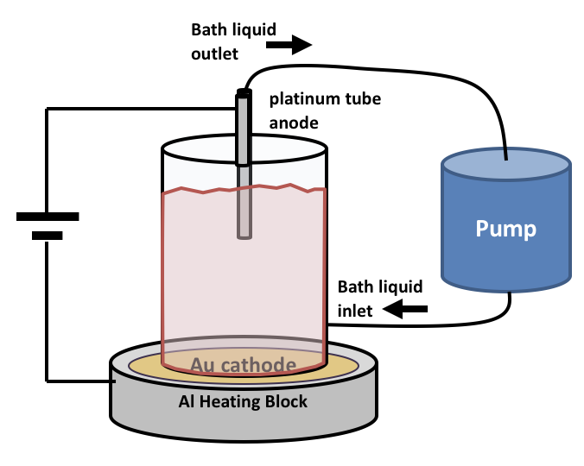

Figure 1. Electroplating chamber schematic.

With Sn dissolved in 11 M HCl, the solution was heated to temperatures greater than 70 °C to remove ether contamination, a necessary step as reaction of ether with bath constituents causes oxidation of Sn²⁺ to Sn⁴⁺ as observed by precipitation of dark solid. After ether removal, solution is neutralized in order to precipitate out Sn(OH)₂. The solid was centrifuged out and dissolved in concentrated H₂SO₄ for subsequent electrodeposition, effectively recycling the ^{nat}Sn.

Results
Dense, thermally conductive ^{nat}Sn targets for proton irradiation were successfully created using a simple electrodeposition technique. Two such targets are shown within Figure 3, with 20x optical magnification accompanying each target image. Good surface uniformity has been achieved in these depositions of >300 mg of metallic species tin.

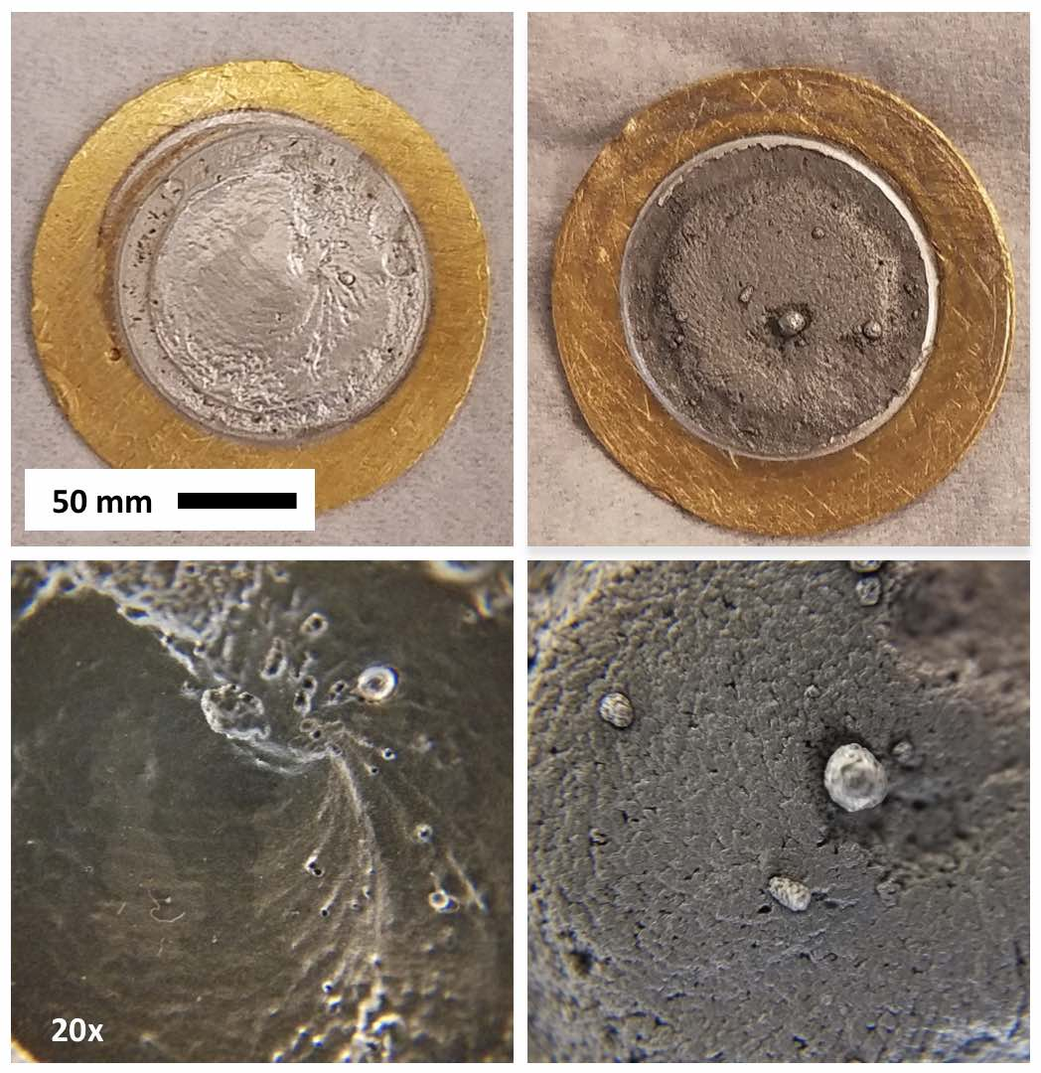
Figure 3. Two ^{nat}Sn cyclotron targets with 20x magnified surface images shown below their corresponding target image.

Electrodeposition of tin mass from solution was recorded in time and plotted within Figure 4. It is observed that >90% of the dissolved tin is plated within the first 5 hours of electrodeposition .

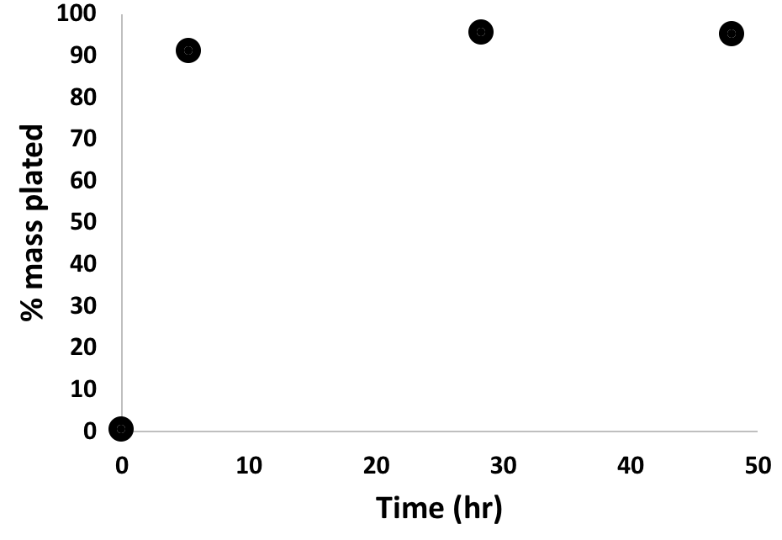
Figure 4. Sn deposition from simple sulfuric acid bath vs time.

Sn targets withstood 16 MeV proton irradiation at currents of 40 µA showing physical deformations depicted in Figure 5. Characterization of the tin recycling efficiency through the tin plating and chemical isolation process is ongoing.

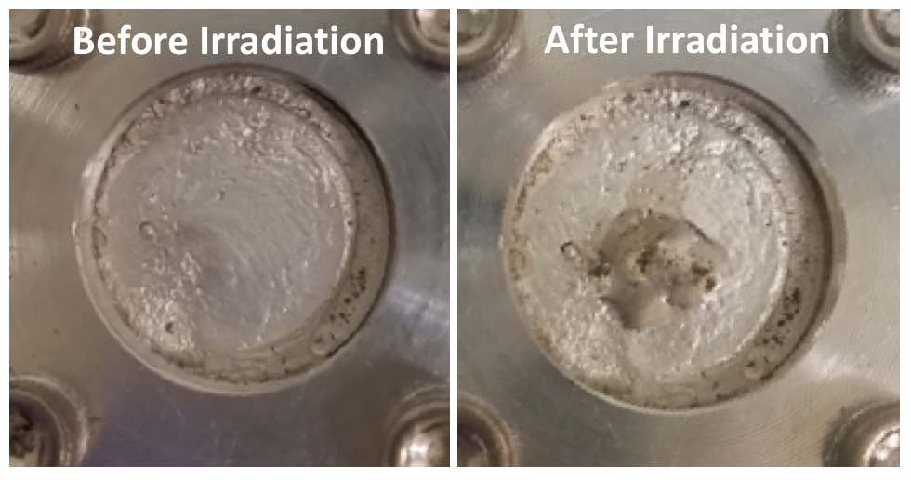
Figure 5. ~230 mg Sn target within Al target mounting before and after proton irradiation.

Conclusion
Production of the Auger-emitting radionuclide ¹¹⁹Sb by proton irradiation of tin targets on small medical cyclotrons offers a scalable route to therapeutically relevant quantities and supplies for preclinical experiments. The necessary use of enriched material will require a dependable tin reclamation process. This work achieves electrodeposition of durable ^{nat}Sn targets and recovery of irradiated ^{nat}Sn following irradiation. Future work will continue to optimize the process, explore alternative separation chemistries, and survey potential chelation ligand candidates.

References
1. H. Thisgaard, M. Jensen: Appl Radiat Isot. 67, pp. 34-38, 2009.
2. J Magill, et. all, Chart of the Nuclides. 9, 2015.
3. A. Obata, et. al: Nucl Med Biol. 30, pp. 535-9, 2003.
4. F.C. Walsh, C.T.J. Low: Surface & Coatings Technology. 288, pp. 79-94, 2016.
5. P. Møller, L.P. Nielsen: Advanced Surface Technology, 2, pp. 243, 2013.

Acknowledgements
The authors would like to thank Drs. Per Møller and Lars Nielsen for advice in the electroplating process.

