CONTROL SYSTEM UPGRADE FOR THE RDS-111 / ECLIPSE CYCLOTRON
Douglas Playle¹

PET Technical Consulting Inc., Ankeny, IA, USA

Introduction
The RDS-111 / Eclipse cyclotron employs an obsolete control system based on discontinued VME hardware. The VM-30 and VM-42 computer boards are no longer manufactured and some of the VME I/O modules are completely unavailable. This creates serviceability concerns and the fatal risk of long breakdowns due to the availability of replacement parts.
PET Technical Consulting Inc has developed a hardware and software solution to completely replace the VME computer and SCADA nodes with a National Instruments control system and a redesigned Graphical User Interface. This commercially available upgrade goes far beyond replacing the obsolete VME hardware, as it also improves production efficiency, simplifies operation, and reduces downtime and service costs by preventing conditions that can cause damage.

Material and Methods
To help ensure future obsolescence is less intrusive we have selected the National Instruments (NI) PXI computer platform. NI has an excellent reputation for making hardware with a long production life and backward compatibility. Our system utilizes standard PXI boards that can be purchased directly from NI. The PXI controller is connected to the cyclotron electronics using custom cables and a small interface board. The User Interface and control programs were created using NI LabVIEW Design Software.

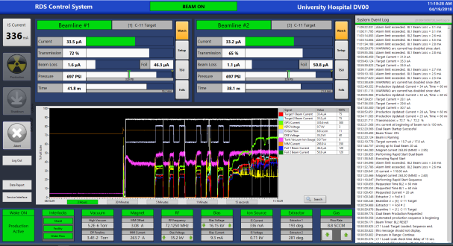
Figure 1. User Interface Production control page.

The completely redesigned User Interface has condensed the multitude of OEM screens down to just two windows. The Production page provides a dashboard view of sub-system status and power supplies, high resolution parameter graphing, performance indicators, and a detailed event log of operations and error messages.
Manual controls are grouped together on a password protected Maintenance page to prevent unintended activation during production.
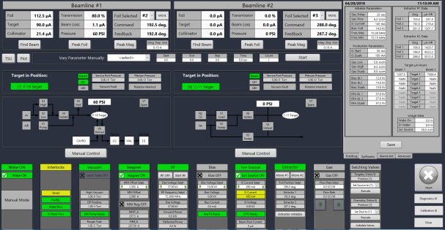Figure 2. User Interface Maintenance page.
User settable parameter limits facilitate a high level of customization to each site's unique operating characteristics and show when key values exceed the normal range. Audible alarms and indicators warn the operator of degraded performance so it can be corrected quickly to prevent damage. These features help reduce downtime, extend the Ion Source life, and reduce the cost of maintenance and consumables.
Improved algorithms for controlling the magnet and beam tuning have increased stability and reduced the beam startup time. A rapid start mode can achieve 50uA dual beam in 2-3 minutes, and single beam takes about 1 minute. Advanced features facilitate automated beam runs even when the cyclotron is running poorly due to issues like excessive RF crowbarring and magnet current controller problems.
Customizable TSU valve control scripts allow greater process flexibility, improve integration of high current and solid targets, and facilitate researchers that operate novel targets and experimental processes. Scripts include the ability to prompt operator to take and confirm actions. PET Technical Consulting can provide ongoing software support for users that desire additional customization and integration.
Results and Conclusion
This platform has been successfully deployed at university hospitals, research centers, and commercial isotope production sites since 2014.
Users report they benefit from having more personnel comfortable running the cyclotron, encounter fewer operator errors, have greater flexibility when delivering targets, run more efficiently due to the added diagnostics, and experience less frequent production delays.

